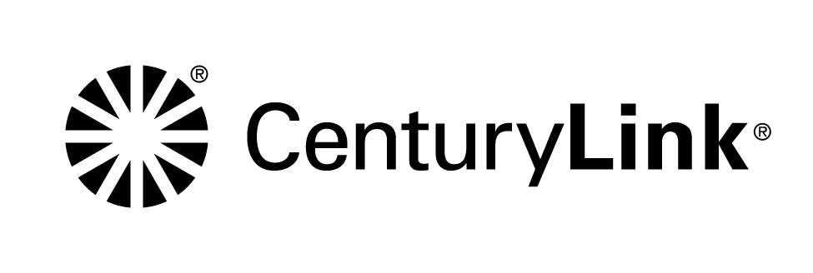

Dear CenturyLink Customer,

**Effective September 5, 2014, the local calling area will be expanded for several Iowa communities provided on the back of this notification.**

Beginning September 5, 2014, you will no longer need to dial “1” before the telephone number when calling between the communities listed on the back of this notice. However, you may need to dial the Area Code plus the number (10-digits) when placing local calls between adjacent Area Codes 515 and 641**.** As a result of this change, you will no longer be assessed long-distance charges for these local calls.

Local service rates will not change as a result of this local calling area expansion. If you subscribe to Measured or Message Service, local usage rates will apply instead of long distance charges when calling within the areas listed on the back of this notice.

**Please note:**

* If you have Speed Dialing, automatic dialing equipment (such as fax machines, computers, or alarm monitors) or call forwarding systems, your telephone equipment may need to be reprogrammed from long distance dialing to 7-digit or 10-digit dialing for the exchanges listed in this letter.
* If you have Toll Market Expansion Line (MEL), Remote Call Forwarding (RCF) services, Foreign Exchange or Foreign Central Office lines into these communities, there may be additional options available to you, such as changing to local services or using Local Number Portability.
* If you currently subscribe to a long-distance volume discount plan, you may want to inquire with your long distance carrier if this change will affect your calling plan.

If you have questions or would like to receive a free account review, please call CenturyLink at the telephone number on your bill, and one of our Customer Care Representatives will make sure you have the products and services you need at the best rate possible. We may be able to show you how to bundle and save even more. The more you bundle, the more you can save on services like High-Speed Internet, Verizon Wireless through CenturyLink and TV Service through CenturyLink.

Thank you for choosing CenturyLink for your communication needs—we value you as our customer.

N-14-189

Page 2

Effective September 5, 2014 the Des Moines Local Calling area has been expanded to include all of the communities listed below. This means you will no longer be assessed long distance charges when calling between these communities.

|  |  |
| --- | --- |
| Adel  Altoona  Ankeny  Bouton  Carlisle  Colfax  Dallas Center  Dawson  Des Moines  De Soto  Dexter  Earlham  Elkhart  Granger  Grimes  Indianola | Martensdale  Minburn  Milo  Norwalk  Perry  Pleasantville  Polk City  Prairie City  Redfield  Runnells  Stuart  Van Meter  Waukee  Winterset  Woodward |