May 31, 2013

Business Record

2013 Woman of Influence Award

To whom it may concern,

I am indeed honored to nominate for the Business Record’s 2013 Woman of Influence Award, Julie Fidler Dixon the CEO of On With Life in Ankeny, Iowa.

I have had the honor of knowing Julie since 2000 when she was trained as a CARF surveyor. CARF is an international accreditation system that looks at the quality of health and human services. On With Life is accredited and has been for many years. Julie is passionate about quality for individuals who have suffered an acquired brain injury. Her organization, through her astute leadership, has weathered the challenging and changing health care system without losing their focus on quality. Very few of our surveyors are chosen to do our international work but Julie is often chosen because of her vast knowledge of the field, her openness to new ways of providing services and her willingness to offer consultation for improvement.

Julie is an active participant in leading health care services as witnessed by her active engagement and participation in task forces and boards on the local, state, and national level. She has been engaged with the Governor’s Advisory Council on Brain Injury since 2004 and has served as Committee Chair from 2005-2010. She has served on the University of Iowa, Graduate Programs in Rehabilitation Advisory Board since 2003 and was the Chair of that group in 2006, 2008, and 2013. She has also served on the Iowa Mental Health/Disability commission and currently is on the legislative mental Health Re-Design Task Force on Brain Injury.

Julie is also an active participant in professional organizations and I have observed her skills in roles as President of the Iowa Brain Injury association and also her active role in the Policy Committee of the Brain Injury Association of America. She holds multiple professional certifications and still has time to run a state of the art organization.

Julie does not stop at professional citizenship but is also active in civic duties including the Rotary Club of Des Moines. She is also the recipient of many awards and honors in her chosen field including the Lou Ortale National Lecturer and the JoAnn Kramer Founder’s award.

Julie has influenced students, families, patients, staff, friends and colleagues to look within themselves and find the strength to make change and improve services whether for those with acquired brain injury, for those in health professions or those in the local community being good citizens.

Thank you for the opportunity to offer this letter of support.

Sincerely,

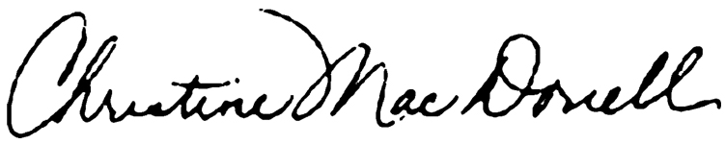

Christine M. MacDonell, Managing Director, CARF International