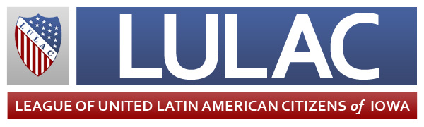

June 13, 2013

On behalf of the Iowa League of United Latin American Citizens, I am proud to nominate Alba Perez for the Business Record’s 2013 Women of Influence awards.

Alba has devoted her entire adult life to community outreach, involvement and engagement of the Latino community, whether it has been through her employment or her membership in various organizations, both with the Latino and mainstream communities.

Alba has a resume full of achievements, but some of her most notable ones are her creation of the initial Latino Business Association, called Alianza; her lead in a 2000 study that examined the Latino community’s contributions to Central Iowa; and her involvement in getting the Latino Heritage Festival and Salsa Iowa (now Salsa Des Moines) events off the ground.

Alba continues to work hard on behalf of the Latino community through her position as director of Latino Affairs for the Iowa Department of Human Services. She has improved access and availability of services for Latinos and is trying to bring services to Iowa that will help the Latino community including a multi-consulate event and a webinar about education access, and she is working with the Mexican consulate on a health guide translation.

Alba is a true inspiration to Latina women. She is a survivor of domestic violence and has spoken about her experiences at Take Back the Night, an annual march and rally held for victims of domestic abuse and sexual violence. She testified to help change Iowa law to make a domestic abuse assault conviction carry a mandatory two-day jail sentence.

Alba believes in propelling women, not just women of color, to a higher level. She regularly nominates promising young women for leadership programs, and she is currently involved with the creation of the Latina Leadership Initiative, a special program created to help give young Latina women the skills and access they need to become the next generation of leaders in the Des Moines-metro area. She helped write the curriculum for the program.

It is because of these reasons and many more that I believe Alba Perez deserves to be named a 2013 Woman of Influence.

Sincerely,

Joe Enríquez Henry,

Iowa LULAC State Director

*\*LULAC is a 5-1(c)(4) organization. Any and all contributions or gifts to the organization are not deductible as charitable contributions for federal income taxes.*

Joe Enríquez Henry

*State Director*

Michael Reyes

*Deputy State Director*

G.G. Sierra

*Immediate Past State Director*

Kirstin Shaw

*State Secretary*

Toni Robertson

*State Treasurer*

Melissa Walker

*State Director for Publicity*

Mary Campos

*Deputy State Director for the Elderly*

Teresa Garcia

*Deputy State Director for Women’s Activities*

Antonio Cedillo

*Deputy State Director for Youth Activities*

Visit www.lulaciowa.org

Visit www.lulaciowa.org

**2463 E Highview Drive, Des Moines, Iowa 50320 • 515-208-7312**

Union Made in Iowa