****

June 5, 2014

Women of Influence

%Business Record

The Depot at Fourth

100 4th Street

Des Moines, IA 50309

To whom it may concern:

It has been my priveldge to have known Nancy Stefani personally and professionally for nearly 30 years. Her reputation and integrity in the non-profit community is unsurpassed.

Nancy was one of the first in her field in Iowa to receive the CFRE (Certified Fund-raising Executive) designation from the national Association of Fund-raising Professionals. With over 40 years of experience in Gift Planning, she has developed a national reputation as a leading authority on planned giving having conducted more than 400 programs on the subject of planned giving for a diverse group of non-profit organizations around the country.

After two very successful careers working for the Diocese of Des Moines and Drake University, we were honored to have her join the Renaissance Group, Inc. team in 2007. She has consistently delivered exceptionally high quality gift planning consulting assistance to a variety of clients including hospitals, schools, colleges, retirement communities and other social service agencies and organizations.

Nancy continues to be a leader in the non-profit community in central Iowa and in my opinion exemplifies the definition of a Woman of Influence.

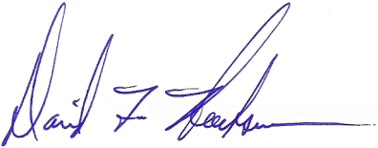

Sincerely,

David F. Hoeksema

President