CHARLES SCHNEIDER  STATE SENATOR  Twenty-second District  Statehouse: (515) 281-3371  –  HOME ADDRESS  7887 Cody Dr.  West Des Moines, IA 50266  C: (515) 554-3213  charles.schneider@legis.iowa.gov | 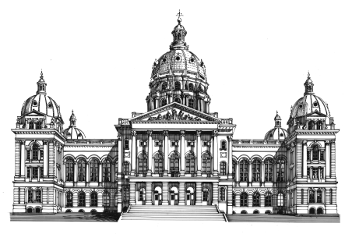  The Senate  State of Iowa  Eighty-fifth General Assembly  STATEHOUSE  Des Moines, IA 50319 | COMMITTEES  Commerce  Economic Growth/Rebuild Iowa  Judiciary, Ranking Member  Veterans Affairs  Ways and Means  Economic Development Appropriations  Subcommittee

June 3, 2014

Women of Influence Nomination Committee
Business Record
100 4th Street
Des Moines, IA 50309

Dear Committee Members:

I am writing on behalf of Sarah Bowman, who has been nominated for this year’s class of the Women of Influence.

I have known Sarah for many years, but I’ve gotten to know her best through her civic involvement in political and historic preservation projects. She is a passionate individual who attracts others to causes with which she’s involved.

One such project was to save the Maplenol Barn in West Des Moines. The barn was located on the grounds of Valley High School and was slated to be demolished to make way for school renovations. Sarah and others saw historic value in the barn and worked tirelessly with the West Des Moines Community School District, the West Des Moines City Council, and others to find a new home for the barn. Their group raised awareness of the barn, mobilized people to save it, and found a person who was able to move it. The barn would not have been saved without their efforts.

Sarah’s political civic involvement started at an early age. At only 26 years of age, Sarah served as Co-Chair of the Polk County Republican Party. At the time, Sarah’s husband had been deployed to Iraq. She was also working a full-time job and raising their first child, who then was just a toddler.

Sarah is also a skilled writer and public relations/communications professional. You’ll see on her resume that she has political and private sector experience. She has been a political writer for several blogs, and even has one of her own.

Sarah has had many successes in her early career. She has also become a leader in her community. I believe she would be a valuable addition to the Women of Influence. Please feel free to contact me if I can provide any additional information that would further her candidacy.

Sincerely,

Charles M. Schneider
State Senator

