June 1, 2015

Dear Selection Committee:

We are pleased to nominate Sally Cooper Smith for the Women Business Owner of the Year award.

Cooper Smith & Company has been the Playhouse's design firm since 2008. In addition to creating images for all of our shows and programs, the company completely re-invigorated the Playhouse's brand with a new logo.

We were initially attracted to Cooper Smith & Company's inviting graphics and their understanding of a non-profit organization's budgetary limitations. We quickly found Sally and her staff to be an excellent guardian of the Playhouse's image, ensuring that all print materials had a cohesive look. They routinely brainstorm marketing solutions, even bringing other clients into partnership with the Playhouse. They are currently working with a programmer to completely revamp the theatre's website.

Sally's involvement in the Playhouse is above and beyond the usual corporate commitment. She serves on the Playhouse's marketing committee. She and her staff attend shows and fundraising events.

Sally holds herself, as well as her colleagues, to the highest standards. We believe that the stability, dedication, and creativity of Sally’s staff are an important indicator of her management ability. She is an inspiration to the organizations with which she works. There is no one who better exemplifies an award-winning Woman Business Owner than Sally Cooper Smith.

Respectfully submitted,

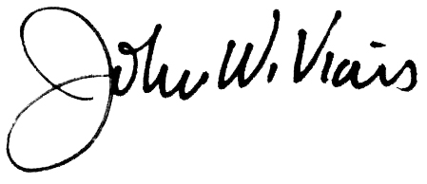

John W. Viars

Executive Director