Monday, June 1, 2015

Dear selection committee of the Woman Business Owner of the Year Award,

I am writing to you in support of Kate Banasiak, CEO and Owner of Diversified Management Services out of West Des Moines, Iowa. As a young professional leader in Central Iowa, it is thanks to business owners like Kate that more young professional women have the opportunity to take risks and explore their entrepreneurial spirit.

I have worked closely with Kate on a volunteer and board leadership level with various organizations in Central Iowa since 2009. After meeting Kate, I was shocked at her age and what she had been able to accomplish. What has been impressive about Kate is not just that she had invested ownership into a company before age 30, but that she was willing to share her experience to inspire other women to consider entrepreneurship and leadership.

As I have experienced different career challenges, Kate has never turned down a request for feedback or guidance. Central to Kate’s leadership philosophy is to share her learning experiences both personally and professionally in an effort to aid others as they are taking professional risks or are considering business ideas.

I can say without a doubt that it is thanks to women like Kate Banasiak that I felt confident to take a risk go after my current leadership position in an industry that is overwhelmingly male dominated. I would ask the committee to consider Kate Banasiak as an excellent candidate for the Business Record Women Business Owner of the Year Award.

Thank you for your consideration,

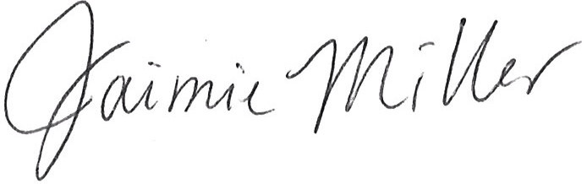

Jaimie Miller
Executive Director
Iowa Credit Union Foundation

