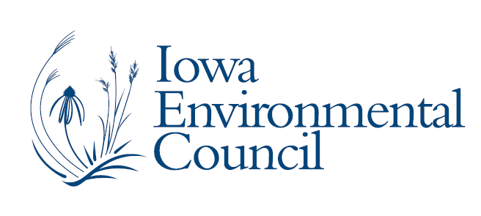

521 East Locust Street, Suite 220
Des Moines, Iowa 50309-1939
515.244.1194 phone
iec@iaenvironment.org
www.iaenvironment.org

June 4, 2015

Dear WOI committee,

It is my privilege to recommend Susan Heathcote to you.

I have known Susan for several years and as the Chair of the Iowa Environmental Council, I have learned the significance of her work and her reputation in the national environmental community.

Susan is the Water Program Director for the Iowa Environmental Council, a nonprofit coalition of 65 organizations in Iowa. She joined the Council in 1996 and has provided leadership in educating and managing many issues including agricultural nonpoint source pollution, livestock manure management, water quality monitoring, water quality standards, and restoration of impaired waters.

In 2007, Susan was appointed by Governor Culver to serve on the Iowa Environmental Protection Commission, which oversees Environmental Programs at the Iowa Department of Natural Resources. She was recently appointed by Governor Branstad to serve on the Watershed Improvement Review Board that provides state assistance to local watershed projects seeking to restore impaired waters.

In addition to her work at the Council, Susan serves on the steering committee and as co-chair of the agricultural workgroup for the Mississippi River Collaborative, a partnership of organizations from states bordering the Mississippi River that work together to reduce pollution affecting the Mississippi River and its tributaries as well as the Gulf of Mexico.

Susan is clearly a leader in the field of natural resources and her work has made a real difference in the quality of life for Iowans.

I respectfully request that you name Susan Heathcote a 2015 Woman of Influence.

Sincerely,

Margi Weiss
Chair, Board of Directors
Iowa Environmental Council

