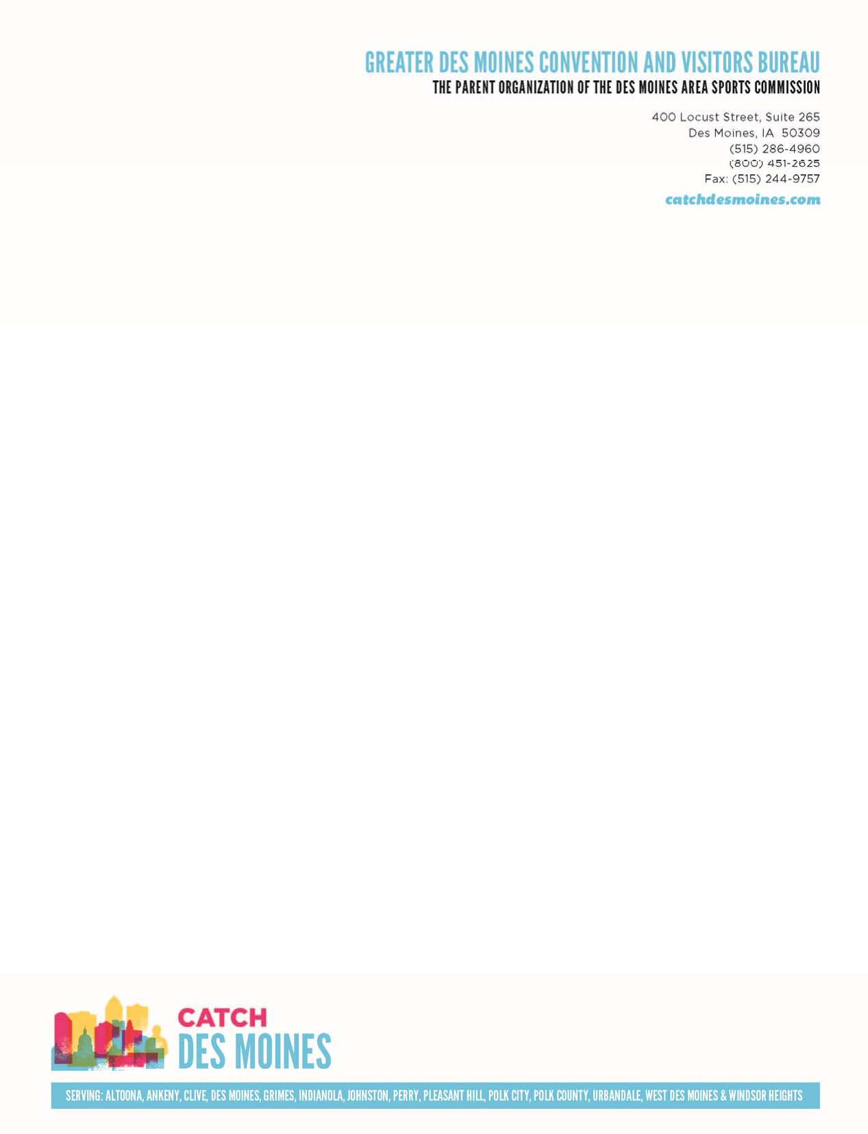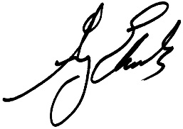

Dear Women of Influence Selection Committee Members,

I am writing to recommend Vicki Comegys as a 2015 Woman of Influence. She is a leader within our organization, the community and on a national level in the convention industry. She is passionate and dedicated, leaving a lasting impact on her field and the entire Greater Des Moines area.

Vicki is a leader in the convention industry. She recently served as president of the Professional Conference Management Association Heartland Chapter and is a Destination Marketing Association International (DMAI) committee representative and instructor. She was one of only four individuals nationwide to be tapped by DMAI to teach hospitality workers of similar-sized cities how to increase convention and event business in Washington, D.C.

– she also made similar presentations to local hotel employees. She has earned the Certified Sports Event Executive designation from the National Association of Sports Commissions. Vicki is also a member of, and involved with, the Hospitality Sales and Marketing Association International, and the American and Iowa Societies of Association Executives.

Locally, she serves on the Greater Des Moines Partnership Diversity Committee, the Des Moines Arts Festival Board, and is involved with the Bondurant Economic Development Board (Chair) and Executive Women International.

Vicki currently serves as our Vice President of Conventions, Sports and Services at the Greater Des Moines Convention & Visitors Bureau. She leads our team of convention and sports sales managers working to develop local and national relationships to bring state, regional and national conventions and events to Greater Des Moines. Vicki has been instrumental in securing groups like the AAU Junior Olympic Games (six times), the American Council of the Blind, the United States Junior Chamber of Commerce (Jaycees), the Gold Wing Road Riders Association National Convention and the upcoming 2017 Ladies PGA Solheim Cup. She was on the ground level, years ago, to develop the framework of the sports market that has since helped us secure large scale events such as the USA Track and Field Championships, NCAA Track and Field Division I Championships, the NCAA Wrestling Championships and others. Through her tenure, she’s helped the GDMCVB land more than 25,000 conventions and sporting events. With her leadership, the sales team booked more than 250 conventions and events, contributing more than $135.6 million in economic impact to Greater Des Moines in fiscal year 2013/2014.

Vicki serves as an inspiration to many. She has great passion for this city and serves as a mentor to planners, local hospitality partners, as well as her sales team and the GDMCVB staff. She gives generously of her time and resources to help put Des Moines in the spotlight. She makes everyone around her better and her impact on this community will be felt for years to come.

Thank you for your consideration of Vicki Comegys as a 2015 Woman of Influence. If you have further questions, please contact me at [greg@catchdesmoines.com.](mailto:greg@catchdesmoines.com)

Sincerely,

Greg Edwards President & CEO

Greater Des Moines Convention & Visitors Bureau | Des Moines Area Sports Commission

**COUNTY OF POLK**

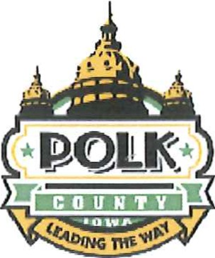

**Board of Supervisors**

111 Court Ave, Suite 300 Des Moines, Iowa 50309-2214

Ph. 515.286 .3120

Fax. 515 .323.5225

Angela Connolly, 2nd District

Ph 515.286 .3117

Email:

anqela .connolly @polkcountyiowa .gov

# June 1, 2015

To the Business Record ,

I am writing in suppm1 of the nomination for Vicki Comegys from the Greater Des Moines Visitors and Conventions Bureau for the Business Record Women oflnfluence award.

I have known Vicki for 17 years and she has consistently gone above and beyond to advocate for and promote the Greater Des Moines area . In her role at the Visitors & Convention Bureau Vicki has been instrumental in numerous high profile projects such as gaining suppmt for the construction of the Iowa Events Center , Hall of Pride and now the Iowa Events Center Convention Hotel. These projects will have a lasting impact on our community for decades to come and her advocacy was crucial.

Vicki 's dedication to the Greater Des Moines community has contributed to unprecedented growth and recognition as a desirable city for businesses , families , young and old. Her passion for our community is also seen through her involvement in non-profit organizations throughout Polk County.

In the many years that I have known Vicki I have always found her to be an honest, hard working, and compassionate person. She should be an example of achievement and integrity for all young women.

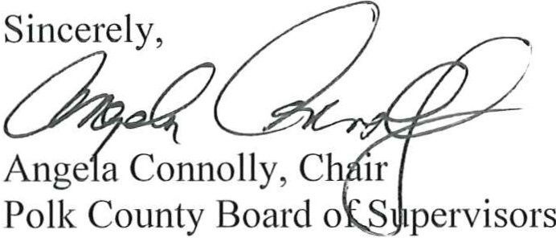

www .polkcountyiowa.gov

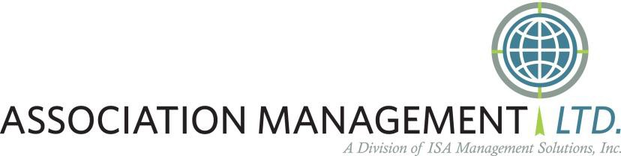

### May 31, 2015

Dear Women of Influence Selection Committee Members,

**It is an honor to support the nomination of Vicki Comegys for *the Business Record’s 2015 Women of Influence* recognition.**

Our firm provides association leadership and management services for state, national and international non-profit trade associations and professional societies. Our members represent a variety of industries across the nation. We work with Convention & Visitors Bureaus regularly as we plan our clients’ conventions and trade shows. Other CVBs can’t hold a candle to ours! **When I mention the Greater Des Moines Convention and Visitors Bureau to my peers across the U.S., people say, “Oh you must know Vicki Comegys! She is amazing!” Never fails. She has made an impact in Iowa and beyond our borders.**

### Last year, the Greater Des Moines Convention and Visitors Bureau, our firm AML and the Iowa Soybean Association partnered together to host the Association Management Companies (AMCs) Regional Forum and Iowa Experience. Our visitors had the opportunity to learn from a national speaker, experience the pulse of Greater Des Moines and enjoy genuine hospitality at an Iowa farm. The educational and networking event brought 50 AMCs from across the U.S. and Canada, representing more than 200 professional associations throughout North America. The mini-conference was a first of its kind. The buzz surrounding the event garnered the AMC Institute’s endorsement, providing continuing education credits for certified association executives (CAE), and stating the inaugural event may be a model for future opportunities. The Greater Des Moines Convention and Visitors Bureau sponsored the event, along with Louisville, Ky., Oklahoma City, and Alberta, Canada convention and visitors bureaus. **Vicki Comegys led the charge for this very unique two-day experience. She is a great champion for Iowa!**

Notable opportunities the attendees experienced included:

* Iowa barbeque and farm-to-table education at the Ron Heck Family Farm.
* Community outreach project with Meals from the Heartland and the Iowa Food and Family Project.
* Speaker John Spence, one of the Top 100 Business Thought Leaders in America.
* Staying at the Hotel Pattee, with a rich tradition and exceptional service, located in Perry.
* Bus tour of Greater Des Moines.
* Tour of the World Food Prize.

**Vicki Comegys is also recognized nationally as a leader and has served in officer roles in her industry associations. She gives back to the industry who has given much to her. She is a role model for up and coming professionals. Her leadership and commitment are demonstrated to anything she touches.**

### Thank you for your consideration of Vicki Comegys. She is well-deserving of this recognition. Sincerely,

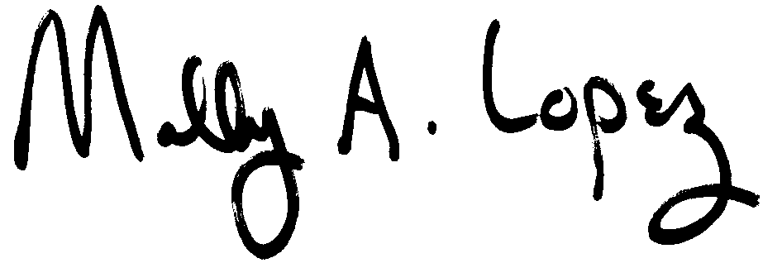

Molly A. Lopez, CAE AML President

1255 SW Prairie Trail Parkway, Ankeny, IA 50023 Telephone: (515) 334-1043 / Fax: (515) 334-1143

Email: [aml@aml.org](mailto:aml@aml.org) [www.aml.org](http://www.aml.org/)