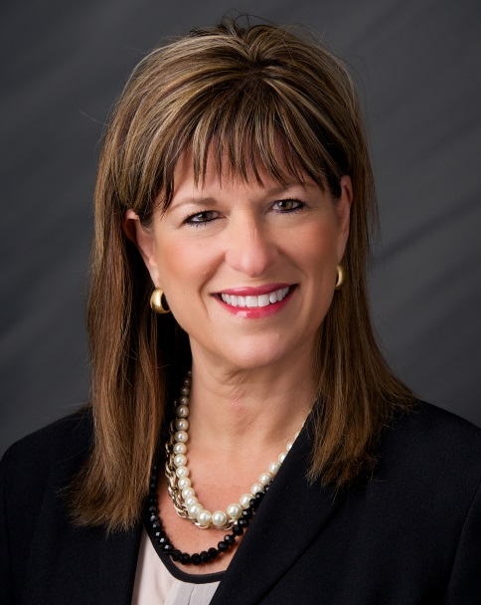

**Marta A. Codina**

**Community Banking Area President**

Marta Codina is a 36-year veteran of the financial services industry who started her career as a teller during high school in Houston, Texas. Marta moved to Iowa in 1994 to join US Bank and worked there for nine years as a regional manager leading the Retail Banking Division. She joined Wells Fargo in 2001 and during her tenure has served as a regional development manager, overseeing sales strategies and learning and development for Iowa, and as an area manager for Wells Fargo Home Mortgage, overseeing the mortgage production sales force for western Iowa.

Marta currently serves as a regional banking area president for Wells Fargo Bank. In her role she oversees western Iowa retail banking operations in a territory that includes Des Moines, Ames, Atlantic, Waterloo/Cedar Falls, Clarion, Denison, Eagle Grove, Emmetsburg, Fort Dodge, Jefferson, Mason City, Perry and Sioux City.

A graduate of the University of Houston, she was a founding member of the Wells Fargo Central Iowa Diversity and Inclusion Council and is immediate past chair of that group, which coordinates Wells Fargo’s local efforts around diversity and inclusion. Marta currently serves on the National Advisory Council of The Robert D. and Billie Ray Center (formerly known as Character Counts in Iowa) and as vice chair – volunteer on the executive committee of the United Way of Central Iowa. She has been a judge for Iowa Homeless Youth Center’s Reggie’s Sleepout Boxed-in Design Contest since 2013 and the 2016 Reggie’s Sleepout Honorary Chair.

Marta and her husband, Jim Bruno, are residents of Waukee, Iowa, and have a son, Nicholas, and daughter, Maddie. Marta is a native of Cuba and came to the United States as a refugee in the early 1960s with her parents. Her passion is around “making a difference” primarily in the areas of early childhood development and diversity and inclusion.