May 23, 2016

Dear Committee Members:

I am honored to write this support letter on behalf of Brooke Knight to be considered for the Business Record’s 2016 Women of Influence.

The Make-A-Wish Foundation of Iowa has had the unique opportunity to work towards fulfilling our mission of granting wishes to eligible children in Iowa and Brooke Knight has helped drive our mission as a member of the Board of Directors since 2015. Not only has she provided her leadership and financial support, but she was instrumental in helping get Businesssolver and its employees to engage in numerous volunteer hours at various events throughout the past few years.

Many individuals talk about the importance of giving back to community and their willingness to help get others involved, but Brooke actually lives that philosophy. Whether it is helping us secure donated funds to Make-A-Wish Iowa through the Businesssolver Giving Campaigns; participating in our Fund-A-Wish Program that directly links her to our mission of sending our WishKids on their one true wish; or being part of our annual Jolly Holiday Lights displays and volunteer opportunities, Brooke Knight is truly a champion for our mission and our kids.

Thank you in advance for your time and consideration of Brooke for this year’s Women of Influence. I cannot think of any other individual more deserving than her. Not only has she touched the lives of our children and this organization but many others throughout Iowa.

Sincerely,

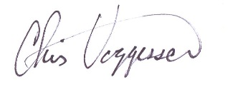

Chris Voggesser

President/CEO