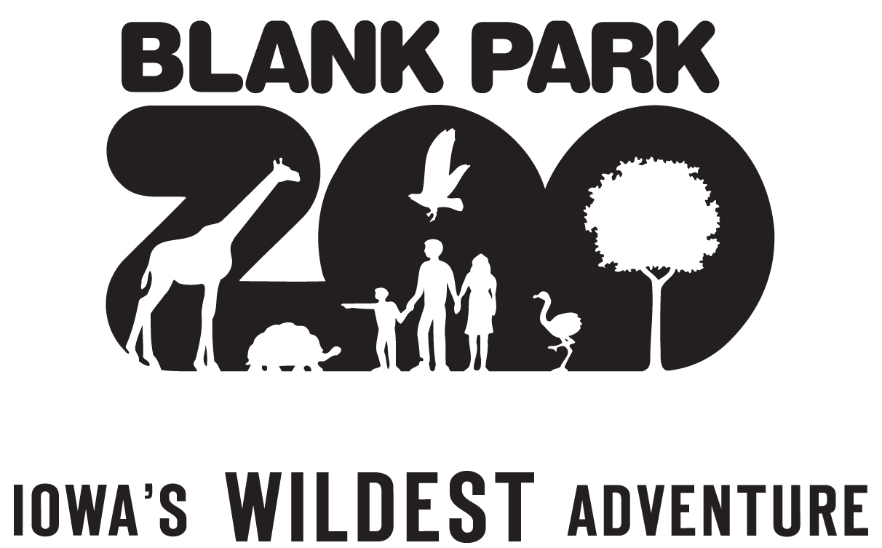

Blank Park Zoo Foundation, Inc • 7401 SW 9th Street • Des Moines, Iowa 50315
Phone 515 974 2538 mrvukovich@blankparkzoo.org

Mark Vukovich
MARK VUKOVICH,
PRESIDENT AND
CHIEF EXECUTIVE OFFICER

BOARD OF DIRECTORS
Executive Committee
Ray Hansen, Chairperson
Toby Joseph, 1st Vice Chair
Richard Hoffmann, 2nd Vice Chair
Rusty Goode, Secy/Treas
Cathy Lacy, Past Chair

Members at Large
Peg Armstrong-Gustafson
James Fleming
Matt Fryar
Pat Henson
James Hourigan
Michael C. Hubbell
Jacob Jaacks
Dotty Thurston
Dean Whitaker
Jonathan Wilson

BOARD MEMBERS
David Brick
Christine Collinet
Russell Cross
Devin Fuhrman
Joe Gatto
James Hagenbucher
Jeffrey Karch
Aaron Kennedy
Tim Kintner
Lisa Kruidenier
Megan Milligan
Lisa Nolan
Christopher Osore
Ben Page
Dustin Petersen
Brian Rickert
Dan Schwarz
Chris Seiberling
David Stark
Jamie Stephens
Julie Stewart

DIRECTORS EMERITUS
David Allen
Judy Blank
Suzy Burns
Robert Burnett
Kaye Condon
Paul Easter
Jo Ghrist
Mary Jean Paschen
John Peterson
Kevin Prust
Billie Ray
Terry Rich
Loretta Sieman
Tim Urban

President and Chief Executive Officer

May 16, 2016

Selection Committee
Women of Influence 2016 Nominations
The Depot at 4th
100 4th Street
Des Moines, Iowa 50309

Dear Selection Committee:

With great pleasure I support the nomination, of Cathy Lacy for the Women of Influence Award.

Blank Park Zoo has benefited from Cathy’s leadership, support and financial generosity throughout the years. Cathy has been a board member since 2008, and currently is serving as past- Chair. Other leadership roles Cathy has been involved with are Chair of Executive and Governance Committee and member participation in Finance and Endowment Committees.

Cathy has been supportive in hosting and facilitating conversations with stakeholders over the years. From hosting holiday gatherings and capital campaign summer lake side events, Cathy believes in hands – on support.

Over the years, Blank Park Zoo has also been fortunate to receive financial support from Cathy for projects like our Zoobilation Gala, and the Wild About Animals capital campaigns, and general operating funds.

Central Iowa is lucky to have residents like Cathy who understands how important it is to get involved with and give back to the community in which you live and work. Blank Park Zoo is just one of the many organizations that has benefited from Lacy’s skills, wisdom, connections and dedication of Cathy throughout the years.

Again, on behalf of Blank Park Zoo, I submit this letter of support for Cathy Lacy’s nomination. I wish the committee luck with its selection as Central Iowa is incredibly fortunate to have such amazing people who have supported this community.

Please feel free to contact me with questions or if you need additional information.

Regards,

Mark Vukovich
CEO

