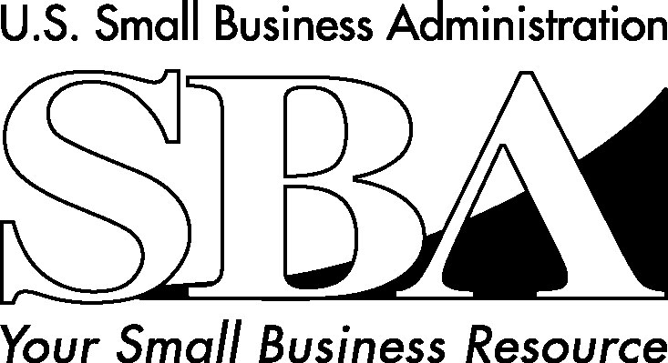 **U.S. SMALL BUSINESS ADMINISTRATION**

IOWA DISTRICT OFFICE

210 WALNUT STREET - ROOM 749

DES MOINES, IA 50309-2186

515-284-4422 • 515-284-4572 (FAX)

May 26, 2016

Women of Influence Awards

Business Record

The Depot at Fourth

100 4th Street

Des Moines, IA 50309

Dear Selection Committee:

It is with great pleasure that I submit this letter of support for Lynn Schreder’s Women of Influence Award nomination. I can’t imagine a more deserving champion of women’s economic empowerment since small business, especially women business owners, are the driving force behind American’s economy.

As the director of the SBA’s Iowa District Office, I have the opportunity to work closely with a large number of women business leaders. During my first year in Iowa I listened and learned from women entrepreneurs who were frustrated that Iowa continued to rank nearly last in the nation for women’s business ownership. While many women business owners found their voices as advocates for change, one truly stood out as the leader of Iowa’s women in business resurgence – Lynn Schreder, president and CEO of KHI Solutions.

Lynn’s commitment to empowering women is best demonstrated through her leadership of the National Association of Women Business Owners (NAWBO) Iowa Chapter. Thanks in large part to her motivational style and passion for small business, the Iowa NAWBO Chapter is now the fastest growing chapter in the country.

Under her leadership as past co-president and board member, both membership and corporate partner revenues have tripled in the past few years. Lynn’s advocacy extends well beyond the greater Des Moines area. In the past year NAWBO expanded statewide with satellite chapters established in Knoxville/Pella, Webster City and Sioux City and with at-large members throughout Iowa.

She continues to open the door for the next generation of women business owners by giving back to the community. She played a major role in the success of the IWLC’s Invest in She pitch events through mentoring and financial support. Her professional expertise and advice are valued by many start-up and expanding small businesses in the community.

Lynn and her business partners overcame significant obstacles to achieve the ultimate American Dream of small business success. KHI Solutions was significantly impacted by industry changes after the passage of the Affordable Care Act. Thanks to their vision, integrity and extensive networking, KHI Solutions re-positioned itself as a leading force of Iowa’s insurance hub. The company has grown to 18 employees with offices in Fort Dodge, Webster City and West Des Moines, and more than 400 agents.

I encourage the selection committee to honor Lynn Schreder with the Women of Influence Award. I can’t think of a more deserving person than one who is impacting Iowa’s economic future by opening the door for the next generation of women business leaders.

Sincerely,

Jayne Armstrong

District Director