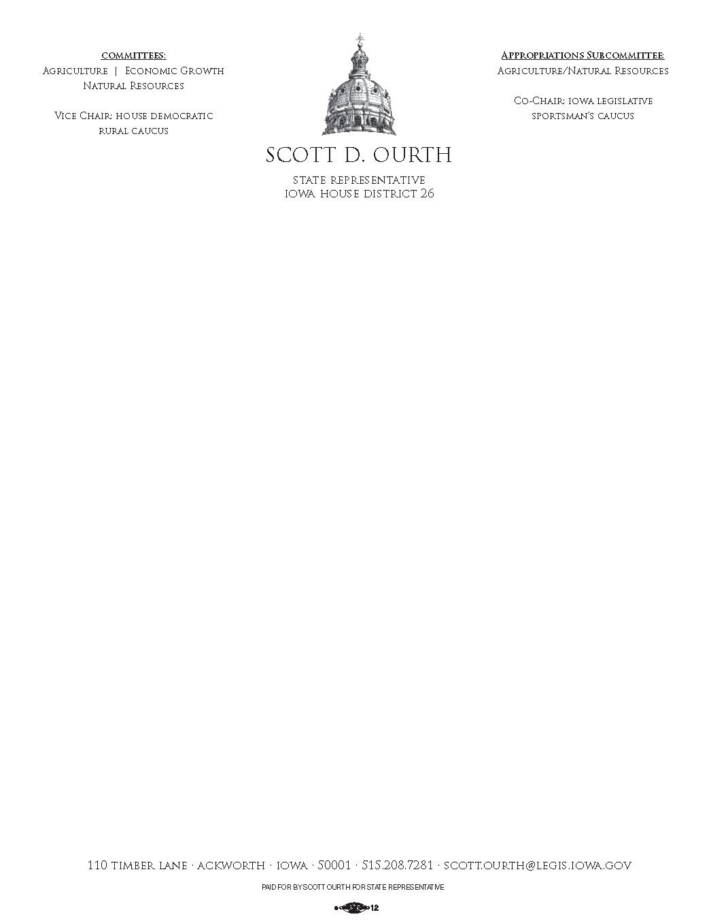

May 27, 2016

To Whom It May Concern:

I am writing today to support the nomination of Mayor Ruth Randleman of Carlisle, Iowa, as a “Woman of Influence” for the Business Record. Mayor Randleman is one of the brightest and most resourceful people I know. I have worked closely with her for the better part of a decade, and have been impressed again and again by the breadth of her knowledge and expertise, her dynamic and energetic nature, and her magnificent work ethic. She is a brilliant student of public policy and has made her life a stewardship of service to her community and to the people of Iowa. Not only is she possessed of a tremendous capacity for learning, she is also a skillful and passionate leader.

Mayor Randleman is a collaborator who works extremely well with others. She is a team-builder. She instinctively identifies the strengths of her partners and skillfully cultivates those strengths to the good of the team and the project. She is a very organized manager and can handle multiple demands simultaneously and effectively. We have worked together on major public projects while she maintained her own separate, aggressive professional workload. She remains cheerful and positive even when faced with frustrating circumstances and daunting tasks. Mayor Randleman can adapt to new surroundings and challenges with no trouble at all. She is amazingly creative, she is a top-notch problem solver, and she is an excellent communicator. Working with Mayor Randleman is an exercise in productivity, efficiency, and fun!

Above all, Mayor Randleman is a portrait of the best to be found in human character. She is honest to the core. She seeks the truth, and she speaks the truth. She is reliable and dependable. If she makes a commitment, she will follow through with dedication and purpose. Her word is her bond. She is empathetic and compassionate. In short, she is an outstanding professional person and an excellent human being. She is that rare combination of fine human of qualities that is so essential to being a force for positive change in the world.

I invite you to contact me and allow me to share more of what I know about Mayor Randleman. You would be well served to examine her closely as you seek to name “Women of Influence” in our community. In my opinion, you will find her to be the best in the field!

Respectfully,



Scott D. Ourth

Iowa State Representative

House District 26