May 25, 2018

Des Moines Business Record  
The Depot at 4th  
100 4th Street  
Des Moines, Iowa 50309

Dear Selection Committee,

It is with great pleasure to offer my recommendation of Kris Saddoris for the 2018 Business Record Women of Influence Award.

As the CEO of Hubbell Realty Company, I’ve had the opportunity to work alongside Kris for the past seven years. After 26 years with Conlin Properties, she made a seamless transition to Hubbell and took over as our Vice President of Multi-Family Development. Kris is visibly passionate, strong-willed and knowledgeable in overseeing the entire development division, including multi-family homes, affordable housing developments and industrial sites.

This year, Kris led her team through the design and approval for Gray’s Station, a $250 million, 75-acre neighborhood in downtown Des Moines. This cutting-edge urban neighborhood melds federal, state and local funders, DART, DNR, DM Bicycle Collective, AARP and employers to bring 1,100 for-sale homes and rentable apartment units to a once-forgotten location in downtown.

However, no one in the community has had an impact on affordable housing more than Kris. In 2016, she and a team successfully created a $2 million capital campaign for HOME, Inc., a Des Moines based affordable housing developer. In the same year, she developed more than 1,000 multi-family units in the metro.

In 2017, Kris was one of 15 members of the Iowa Walking College Challenge; she’s a leader for Smart Growth Iowa and a founding member of Commercial Real Estate Women (CREW). In 2015, Kris was named Citizen of the Year by the Downtown Chamber of Commerce and that speaks volumes to her community involvement. She worked relentlessly in 2014 to establish an Urban Land Institute chapter in Iowa and in 2010; she was honored with the prestigious Kay Anderson Friend of Iowa Award from the Iowa Finance Authority.

Kris’s critical thinking skills paired with her profound background has earned respect from her Development team and Hubbell Realty Company employees. Kris continues to aw us all and deserves to be awarded with the 2018 Women of Influence Award.

Sincerely,

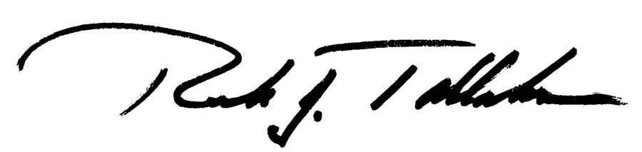

Rick Tollakson, CEO Hubbell Realty Company