May 2018

It is with great pride that we, Kemin Industries, recommend Lauren Burt for the 2018 Meredith Emerging Woman of Influence Award.

We have had the pleasure of calling Lauren our colleague for almost a year and a half now, and in that brief time she has made an immense impact on the company. As worldwide communications manager, Lauren has greatly enhanced our external communications, implementing a number of strategies to increase our media presence globally, streamline the process of doing so and expand the Kemin brand footprint. She has guided Kemin into social media and boosted recognition of the Kemin name within the Des Moines community. Lauren oversees sponsorship and community engagement initiatives locally and globally, a responsibility she’s more than qualified for, given her numerous volunteer endeavors.

Lauren has served as Junior League of Des Moines President and is on the boards of the Greater Des Moines Public Art Foundation and Bravo Greater Des Moines. She is a former State Commissioner for the Iowa Commission on Volunteer Service and received the Lt. Governor’s Volunteer of the Year Award. Lauren was named Young Professional of the Year by The Des Moines Register and Juice and is a member of “Forty Under 40.” Her list of accolades and contributions continues, but Lauren’s qualifications for this award go beyond her involvement.

Lauren is a consummate professional. She is articulate, ambitious and carries herself with confidence. Stress does not show on Lauren; she remains calm and collected in the most harried situations, demonstrating respect and thoughtfulness at all times. Her accomplishments are many, but Lauren’s poise, positive attitude and consideration for others are equally emulative.

Although it’s hard to consider Lauren an “emerging” woman of influence with all she’s achieved at a young age, her drive and commitment to giving back and bettering the community will no doubt keep her active and engaged in professional and charitable endeavors for years to come.

She has worked in state government, nonprofits and major corporations. During her time with the Greater Des Moines Partnership, she secured over 75 national media placements, including Forbes’ #1 City for Young Professionals. Lauren has a strong dedication to this city and a deep desire to improve the quality of life for those in it. At Kemin, her service to others has expanded globally. She’s traveled with the World Food Programme and helped direct our company’s philanthropic dollars toward worthy causes.

Lauren Burt has been, and will continue to be, one of the most admirable, altruistic and influential young professionals in Des Moines, and we cannot think of another woman leader more deserving of this recognition. We enthusiastically recommend Lauren Burt as this year’s Meredith Emerging Woman of Influence Award.

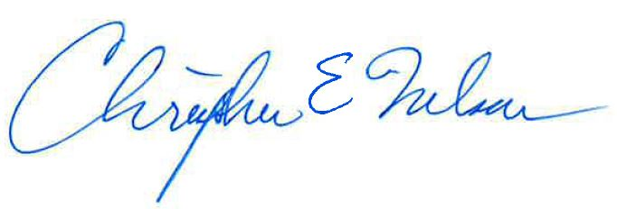Best regards,

Christopher E. Nelson, PhD

President & CEO

Kemin Industries, Inc.