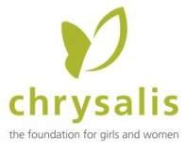

May 21, 2018

Jason Swanson

Des Moines Business Record 100 4th Street

Des Moines, Iowa 50309 Dear Mr. Swanson,

On behalf of the Chrysalis Foundation, I’m honored to support the 2018 Women of Influence nomination of Jan Berg Kruse. In my experience, Jan’s personal and professional support to me and to Chrysalis has been of significant benefit and deserves recognition through this award.

My experience with Jan evolved from a business relationship, as she helped the foundation in its search for a new office location. From analyzing space needs to advising on location, she gave extensive guidance to me and to Chrysalis board members in selection, negotiations, and ultimately, design of new office space in newly-renovated East Village.

In 2004 and 2005, Jan supported Chrysalis in making business and personal connections for an upcoming celebration, using her broad community knowledge and her various relationships. She was instrumental in helping finalize various event details including sponsorships and income.

Over the years, Jan has provided financial and in-kind support to Chrysalis in immeasurable ways. She is an inspiration to me and a role model for many women who aspire to develop people-oriented professional relationships with a reputation for quality and integrity.

I wholeheartedly recommend you select Jan Berg Kruse as one of the Business Record’s 2018 Women of Influence.

With warm regards,

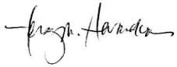

Terry M. Hernandez Executive Director

300 East Locust Street, Suite 245

Des Moines, IA 50309 Phone 255.1853