Quote from Renee Thomas in the Des Moines Register’s Trans in Iowa piece by Courtney Crowder:

*“You advance a cause by coming out and being visible. I’ve had people say to me, ‘You’re very brave (for being public).’ That’s not it at all. I have a sense of responsibility to myself and to all the trans kids who need to know there is nothing shameful about this, nothing about this that makes you anything less than. Being who you are, whether that is transgender or not, is right and just and good. You have to be proud of who you are, and I promise, you got a lot to be proud of.”*

Trans in Iowa series feature Renee Thomas in the Des Moines Register:



https://www.desmoinesregister.com/story/news/2016/06/09/transgender-iowans-trans-iowa/85496126/

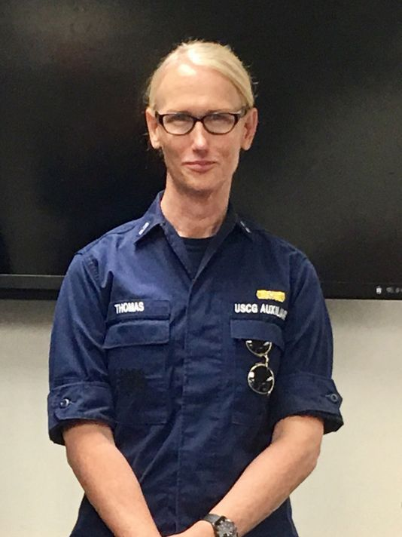**Piece in Des Moines Register featuring Renee Thomas and her deployment in the coast guard as an out transgender woman:**

https://www.desmoinesregister.com/story/news/2017/09/08/transgender-iowan-renee-thomas-hurricane-irma/644670001/​

​

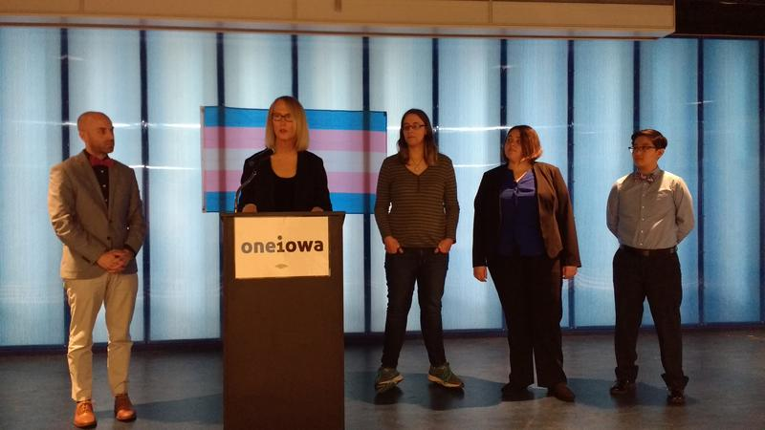**Article with picture of Renee Thomas speaking at One Iowa's press conference:**

http://iowapublicradio.org/post/activists-say-survey-trans-and-gender-nonconforming-iowans-shows-unacceptable-realities#stream/0 ​

**Renee Thomas featured in a podcast:**https://soundcloud.com/user-548478055/episode-12-renee-thomas-a-transgender-coxswain-of-the-us-coastguard