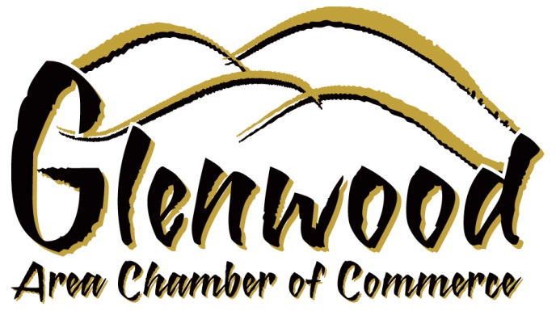Glenwood Area Chamber of Commerce

Glenwood, Iowa 51534

[www.glenwoodia.com](http://www.glenwoodia.com)

[linda@glenwoodia.com](mailto:linda@glenwoodia.com)

To: Des Moines Business Record

RE: Commercial Real Estate Professional of the Year Nomination for Mike Macri III

Please accept this letter of nomination for Mike Macri III, Ferguson Commercial Real Estate, for the Business Record’s CRE Professional of the Year. I worked with Mike over the course of several years through the Mills County Economic Development Foundation, Inc. I was the Director of both the Chamber and Economic Development until July 31st of this past year. Mike brought his professional expertise to Mills County by doing an assessment of what our county needed in an underdeveloped area that had just opened up for development with the new Highway 34 and Missouri River Bridge Corridor that created another transportation access between Iowa and Nebraska. He put together a market analysis and made numerous presentations to our board and our Mills County Supervisors and elected officials. Mike was able to bring Love’s Travel Stop to Mills County from his years of building relationships with many companies and real estate developers. For Mills County, this was a significant achievement, all due to Mike’s expertise and ability to match our county’s needs and assets with a client that fit for growth and development in this area.

I highly recommend Mike Macri III as your Business Record CRE Professional of the Year. Although I can only speak to his success in working with us in Mills County, he is professional, knowledgeable, and holds himself to the highest ethical standards. He is a true real estate professional!

Attached to this letter, you will also see that due to Mike, we will be breaking ground in a few short weeks on our Love’s Travel Spot facility.

Best Regards,

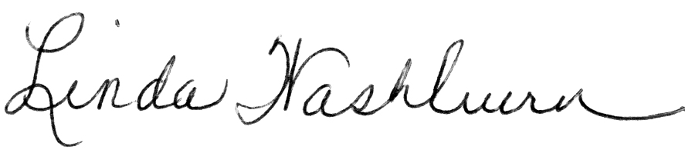

Linda Washburn, Executive Director, Glenwood Area Chamber of Commerce