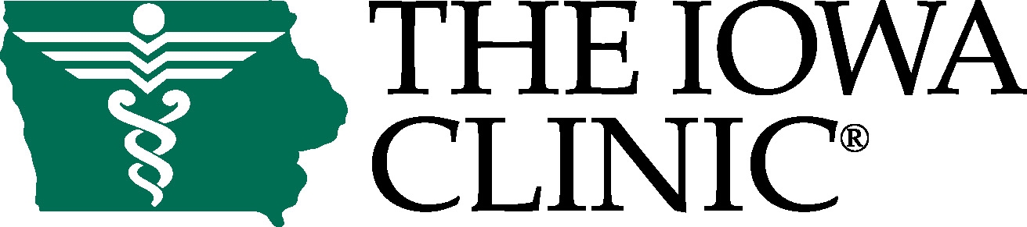

December 17, 2015

Re: David Zielke CFO of the Year Recommendation Letter

Dear Selection Committee:

It is my honor and privilege to recommend Mr. David Zielke for the Chief Financial Officer of the Year Award.

Imagine you work for one of the largest employers in the Greater Des Moines area as the Chief Financial Officer (CFO). The organization is privately owned with over 123 shareholder owners who are personally involved in the business. Now imagine they are all physicians! That is the role Mr. Zielke has played over the past 10 years at The Iowa Clinic.

I recruited David away from one of the largest and most prestigious multi-specialty clinics in the country where he served in a financial leadership position. He already had an excellent reputation, but I felt he could take The Iowa Clinic to the next level. During his tenure, he has proven that he was up to the task.

Healthcare is a unique industry that is going through major transformational changes. It is in the face of this economic metamorphosis that David’s unique skills have transcended above the typical role of a CFO. Physicians are very intelligent individuals who commonly face medical issues that need to be assessed, evaluated and diagnosed. While they are well trained and excellent at doing this in the medical sciences, they are not so familiar with economics and the business of healthcare, yet have a deep desire to understand. In the medical world it is common to question and challenge one another for the correct answer. This is the same level of interest they have in understanding the business of healthcare.

Mr. Zielke has the uncanny ability to take complex issues and break them down into a story that our physician leadership can easily follow. He anticipates the complex alternative financial approaches to a solution and is informative to each option’s implications. The art of doing this, within our system of care, is to relate it to the physicians who are at all levels of understanding.

During our decade together we have worked as a team. We have grown nearly 40% from a $89M to $147.5M healthcare company. Our Physician Shareholders have grown 22% from 96 to 123 and overall employees have grown more than 24% from 648 to 858. All of this growth has also resulted in the expansion of campuses from 2 site locations to 9 primary locations in the Greater Des Moines area and more than 25 satellite locations throughout Central Iowa. He is not one to stand on his accomplishments, but it is honestly not necessary because they can be seen throughout our entire organization and city. David’s finger prints are all over our largest successes - growth and expansion, state-of-the-art technologies, and numerous community partnerships with payers and local hospital systems.

With all of his busy work obligations, David Zielke takes the time to give back to his community. He is a member of the Board of Directors at On With Life, a not-for-profit organization and Midwest leader in brain injury rehabilitation and active with our own Iowa Clinic Healthcare Foundation. He is also very active in his church and has been a long time congregational leader. On top of this, he is a devout husband, father and grandfather.

I hope you will give serious consideration to Mr. Zielke and his contributions for the Deloitte Chief Financial Officer of the Year Award.

Respectfully submitted,

C. Edward Brown
Chief Executive Officer

