December 17, 2015

Deloitte CFO of the Year Award Nomination

David Zielke serves on the management team of the Iowa Clinic as Chief Financial Officer.

In addition to fulfilling the role of the CFO - reliable financial statements, financing and coordinating tax compliance matters, David works with Ed Brown, CEO, in serving as an integral part of the Clinic’s visionary team. He thinks about the future. Remember, a visionary isn’t a predictor of the future, but someone who looks at where the Clinic is now and gives thought to where the Clinic should be. Jim Collins in his book Good to Great says “Leaders give people their freedom, but freedom within a framework”. The framework being the strategic plan. David is a very significant part of the Iowa Clinic Strategic Team.

Though David may appear to being mild-mannered, he exhibits a great deal of strength in solving problems. I would describe David as strong willed. It is the responsibility of the CFO to uphold high standards throughout the Clinic. It takes leadership from the top to communicate this commitment, monitor adherence and take swift action when David sees the standards being relaxed. David’s oversight in this area is rarely questioned.

Building consensus is one of David’s many strengths. An effective CFO achieves a blend between being a decision maker and a consensus builder. Get the decision made, but develop a consensus. As CFO, David does not dominate nor intimidate but provides his team with the motivation to achieve the objective.

Dealing with physician behavior and accountability is perhaps the most challenging aspect of David’s position as CFO. A clinic will go only so far as the physicians will take it. So, it stands to reason that clinics will be better off if there are systems in place to establish physician accountability. David, as CFO, is very instrumental in formulating and maintaining these systems.

Many CFOs who isolate themselves only know their own clinics. David, on the other hand, takes advantage of outside resources in the field of medical management. He participates in management roundtable groups, attends MGMA conferences and engages in other activities that provide a wealth of information and new ideas to the Clinic.

I have been in public accounting over forty years and experienced may individuals in the role of CFO. David Zielke is up there with the very best and deserves to be the Deloitte CFO of the Year.

Very truly yours,

DENMAN & COMPANY, LLP



Tom Ahlers, Partner

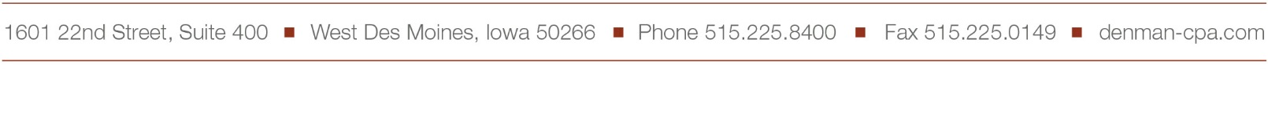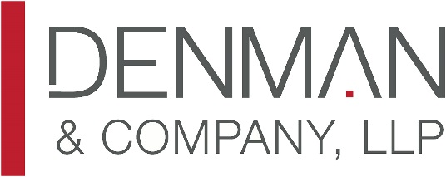TA/bjs