CliftonLarsonAllen LLP

2700 Westown Parkway, Suite 400

West Des Moines, IA 50266

515-222-4400 | fax 515-222-4444

CLAconnect.com



Nexia-PMS-540-Original-Artwork.emfDecember 14, 2015

Mr. Patrick S. Jury, CAE, Chief Executive Officer

Iowa Credit Union League

1500 NW 118th Street

Des Moines, Iowa 50325

Re: Letter of Recommendation – Des Moines Business Record CFO of the Year

Dear Pat:

It is my understanding that you intend to nominate Mike Powers for the Business Record’s CFO of the Year. I also believe Mike to be a very deserving nominee.

Based on my experience in working numerous years with Mike in a professional relationship, I believe that Mike exhibits many of the attributes of the successful CFO. Among other things, I think Mike especially exhibits the following traits:

Strategic Vision – Most importantly, I have been impressed with the entrepreneurial and visionary mindset of Mike. That means he is more than just a numbers guy. He seems to be looking for innovative solutions to issues that will benefit the ultimate stakeholders – the credit union members.

Industry and Company Knowledge – Our various interactions on financial and businesses issues revealed that Mike’s depth of knowledge goes beyond merely reporting the score. He demonstrates an interpretive ability that adds value based on a true understanding of the credit union industry’s fundamentals and ICUL’s operations and its business model.

Character – An excellent CFO must be honest, ethical and able to develop and maintain the trust and confidence of all constituents. I have observed no instances where Mike was not upstanding and straightforward. Moreover, working with him has always been a pleasure.

I could go further, but believe I have expressed succinctly my regard for Mike Powers. If anything further is needed, I would be happy to respond.

Very Truly Yours,

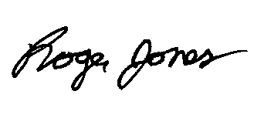

Roger C. Jones, CPA

Principal