I am writing this letter to recommend Cammy Leners for the 2014 Deloitte CFO of the Year award. I have been on the Board of Directors for the Winterset Community School District for over ten years and acted as Board President for the last eight years. During that time I have had the pleasure of working with Cammy during good times as well as through some difficult financial times.

Cammy possesses many strengths, she is a very responsible and dedicated person and always has our districts best interests at the forefront. Our district had fallen into a serious financial situation and through her outstanding performance as our CFO we were able to correct that, turning our crisis into a positive in two years. She multi tasks and never lets down our expectations.

I highly recommend Cammy Lenners as the 2014 Deloitte CFO of the Year

Sincerely,

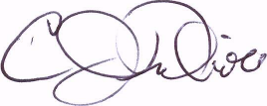

C.J. Nicholl, Board President

Winterset Community School District