December 8, 2017

Deloite CFO of the Year Award

To Members of the Selection Committee:

It is an honor to write you in support of Steve Kukla’s selection for the 2017 Deloite CFO of the Year Award. Having worked closely with Steve as a volunteer at Mercy and Mercy Health Network for over 20 years, I feel very qualified to write this letter of recommendation.  He is extremely qualified based on your selection criteria of significant achievement and success within their profession and company as well as possessing personal and professional reputations showing high ethical standards.

In addition to the specific attributes and qualities the individual selected for the CFO of the Year Award must possess, the following is a brief overview of his many achievements:

* After receiving his B.S. Degree in Management/Accounting, Master Degree in Public Administration and CPA from the State of Illinois, Steve made a decision to focus his career in Healthcare. As such, he continued his studies achieving Advanced Membership in the Healthcare Financial Management Association and completed the Executive Program in Managed Care at the University of Missouri - Kansas City.
* Over the past 36 years Steve has worked tirelessly to have a positive impact on the both the organizations he became a part of, but also in the case of the Medical Centers, the patients served. From his first position as a Finance Manager with the American Hospital Association in Chicago, he most recently has provided accounting and financial oversight of 43 hospitals and 200 clinics across the State of Iowa.
* He is committed to volunteering time and talent within his chosen industry. Throughout his career Steve has given of his time and knowledge to healthcare related organizations. Some of those organizations include the Iowa Hospital Association, Childserve and the Iowa Blood Bank. Additionally, he has served on most every committee and board within the Mercy Organization in Iowa that has dealt with the quality of care and the changing healthcare environment. In all cases he has provided valued advice and leadership.

In closing, Steve Kukla is a very deserving candidate for this most important recognition. As a talented financial executive, Steve made a decision early in his career to make a positive and lasting difference in the lives of many. When the Sisters of Mercy built the first hospitals in the state of Iowa, their founding principles were reverence, integrity, compassion and excellence. Those words clearly define Steve Kukla.

If there is any additional information I can provide, please contact me at your convenience at 515-202-2611.

Respectfully submitted,

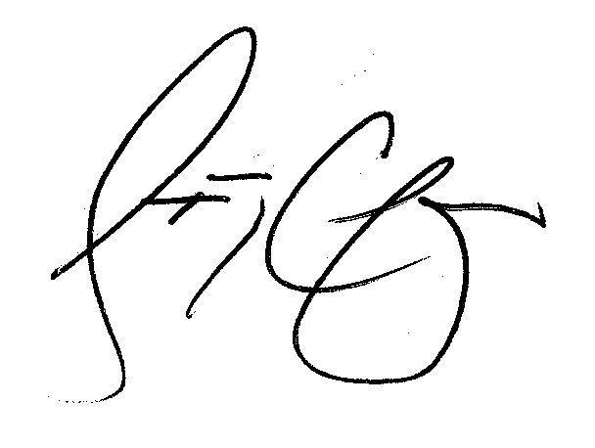

Steven G. Chapman