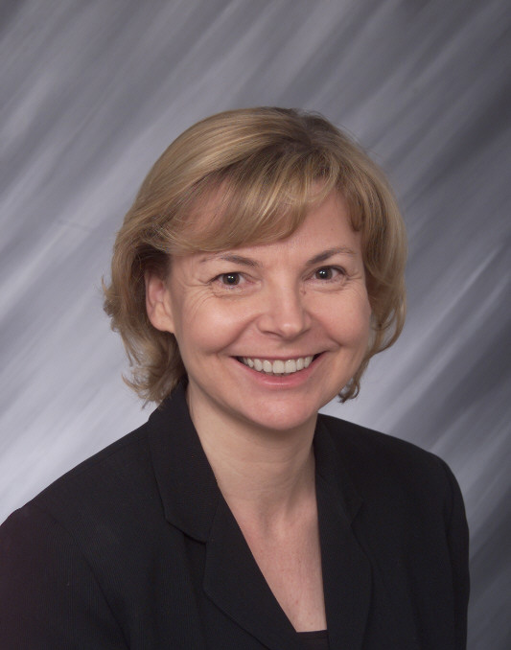
It is our pleasure to nominate Ellen Willadsen for the honor of Deloitte CFO of the Year. Ellen exemplifies the values of a corporate financial steward and has been instrumental to the significant growth and success of Holmes Murphy & Associates, currently ranked 26th largest of America’s insurance brokerage firms.

Ellen joined Holmes Murphy in 1995 as Controller and was promoted to Vice President of Finance before earning the title and responsibilities of CFO. Since joining the firm, Holmes Murphy’s revenue has increased by more than $95 million. Willadsen contributed to this success through her counsel and advice to the firm’s management team during milestone business decisions, in addition to overseeing the ongoing, traditional financials.

Among the significant milestones Willadsen has provided her expertise in leading business analyses and acquisitions that have resulted in adding 9 Holmes Murphy branch offices throughout the United States and folding numerous acquired books of business into our core operation. During the current year, Ellen led teams related to due diligence and integration of one divestiture and two pending acquisitions.

Willadsen helped lead Holmes Murphy through the conversion from a C corporation to an S corporation. During her tenure, the company also converted from tax basis financials to GAAP and a full financial statement audit. This year she is also working on a corporate restructuring which is critical to Holmes Murphy’s continuation of private ownership. These important milestones for Holmes Murphy included a large amount of analysis, which she spearheaded to lead Holmes Murphy to make informed and intelligent decisions. Her attention to detail, hard work and expertise was invaluable during this transition.

As a privately held company, Holmes Murphy is not held to the same regulations that public companies are. Therefore, Willadsen oversees that Holmes Murphy treats management/owners such as shareholders and division leaders consistently and equally in regard to financials. She currently sits on the perpetuation, audit and compensation committees, helping to balance individual needs with the company’s goals and desire to stay privately held. In addition, she helps others in the firm embrace the core company values, which include integrity. From a financial standpoint, Willadsen is instrumental in instilling integrity throughout to ensure all Holmes Murphy employees consistently do the right thing when it comes to managing the dollars. Her valuable contributions to the firm help Holmes Murphy stay course and continue to increase profitability.

Willadsen also has made her mark as a highly respected manager and leader, which speaks for itself when evaluating the longevity of her department employees. This is another compelling reason why Ellen Willadsen should be the next Deloitte CFO of the Year. She manages a staff of 12 employees, and 80 percent have been there for more than five years, one-third over 15 years. Willadsen’s accounting department is known within Holmes Murphy as being a department that works well together and performs like a well-oiled machine.

The accounting department’s reputation is a result of Ellen Willadsen encouraging a family-like atmosphere, fostering continuing education and following the company’s core values. Accounting is bottom-line, but it’s also about people’s lives. Ellen Willadsen believes that if you provide people with a vision and back it with challenging opportunities, they rise to the occasion. That’s why motivation and recognition play such large parts in her leadership style and department culture.

Ellen Willadsen pays attention to the development of others — creating opportunities for them, and sharing the responsibilities, as well as the rewards, of success with them. Each year, an intern from Drake University’s accounting program is offered a yearlong internship program in her department. Also, under Willadsen’s leadership, she has provided direction and mentoring to multiple employees who have gone on to obtain advanced degrees and/or designations such as the Certified Public Accounting designation.

Outside of work, Ellen Willadsen has served on the United Way WLC Investment Committee for a number of years. She is also a member of the ISCPA and sits on the organization’s Continuing Education Committee.

