**Happy 20th! Court Avenue Brewing Co. led district revival**

[Mike Kilen](http://www.desmoinesregister.com/staff/17849/mike-kilen/) , mkilen@dmreg.com 12:17 a.m. CDT September 4, 2016

Facebook[Twitter](https://twitter.com/intent/tweet?url=http://www.desmoinesregister.com/picture-gallery/news/2016/09/01/photos-court-ave-brewing-co-celebrating-20-years/89729890/&text=Happy%2020th%21%20Court%20Avenue%20Brewing%20Co.%20led%20district%20revival&via=DMRegister)[Google+](http://plus.google.com/share?url=http://www.desmoinesregister.com/picture-gallery/news/2016/09/01/photos-court-ave-brewing-co-celebrating-20-years/89729890/)[LinkedIn](http://www.linkedin.com/shareArticle?url=http://www.desmoinesregister.com/picture-gallery/news/2016/09/01/photos-court-ave-brewing-co-celebrating-20-years/89729890/&mini=true)

Photos: Court Ave Brewing Co. celebrating 20 years

Court Avenue Brewing Co. owner Scott Carlson blows the foam off a mug of Honest Lawyer IPA in the brewery. CABCO is celebrating the 20th anniversary of the brewery and restaurant in Des Moines.  Rodney White/The Register

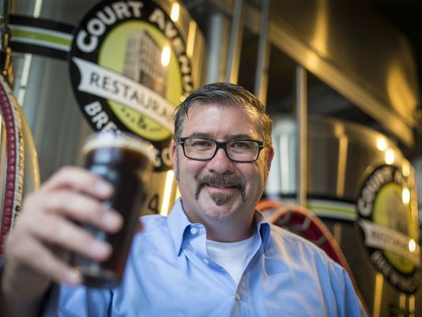

(Photo: Rodney White/The Register)

Scott Carlson pushed employees not just to perform better but to be better. The kind of person who pulls over on Hickman Road and helps a stranded motorist, like his general manager Justin Berkley did a few days ago.

“I know he’s a humble guy, but he’s one person that sets that precedent — good for the sake of good, the same reason I drove up and stopped that day," Berkley said. "You can be light or you can be dark, but you reap what you sow, man.

“People always asked me, ‘What’s Scott’s ulterior motive?’ That question insults me,” Berkley continued. “When I watch the news, I realize the ratings are in the negativity. But, no, there are still people who think it’s cool to be good — and still have a good time, bro. I’m sorry if I’m talking too much. Basically, he taught us to be good.”

In case you couldn’t tell, Berkley got his start as a talkative bartender at Court Avenue Brewing Co. Today, he is the general manager.

Carlson, managing partner of Court Avenue Brewing Co., and his current and former employers he mentored, said the success of the business that celebrates its 20th year on Sunday has as much to do with selling good feelings as craft beer, now a thriving trend that his brew pub was among the first to make on the premises in modern times.

Court Avenue Brewing Co. wasn’t just a key centerpiece of the revitalization of Des Moines’ oldest entertainment district after the 1993 floods — it bred an environment that helped form the hospitality philosophy of countless servers and bartenders who went on to own or manage their own restaurants.

Tony Lemmo (Aposto, Gusto), Tag and Megan Grandgeorge (Le Jardin), Carl Wertzberger (Gilroy’s Kitchen +Pub +Patio) are a few that went on to make their own mark, as well as loyal customers who went on to start breweries.

Carlson, 46, said he chose his employees based on their ambition and talent but shared his oft-repeated refrain that his brew pub was serving up feelings, not just a side of ranch. His restaurant group, Side of Ranch Inc., today includes Court Avenue Brewing Co., Gilroy’s in West Des Moines and Americana in the Western Gateway.

“It’s not a concept,” Carlson said recently over lunch. “It’s a place.”

**Carlson moved all over the country** as a kid, as his father held jobs on each coast, Chicago and London. Dining out in each new city was a staple of his growing-up years.

He came to Des Moines to attend Drake University for marketing, taking a particular interest in the hospitality and restaurant industries. There he met his future wife, Kristin, a Des Moines native, who asked him to stay. He had no such designs before meeting her, figuring he would drift with the opportunities of an independent restaurant group.

“I told her I would stay if I could find a job,” he said.

He did with some quick thinking. He saw the beginnings of the brew pub trend start to unfold, as Babe’s Brewery was making a short-lived run, as well as a brew pub in Adel that didn’t last. Two other groups were beginning plans to launch a brew pub in Des Moines, so he talked to them both, and said he was hired by both. He eventually went with a group called K.C. Hopps, which opened the brew pub in the historic Saddlery building on Court Avenue that once housed such various businesses as a saddle shop and the Kaplan Hat Co.

Court Avenue had fallen on hard times. Though it had been an entertainment district dating back to the 1800s, the floods of 1993 closed many longtime staples, and the Saddlery sat empty for three years. What was left near Court was a smoky sports bar, Johnnie’s Hall of Fame, Spaghetti Works and Java Joe’s coffee shop.

“We were a significant piece (of the comeback),” said Carlson, who was hired as a manager.

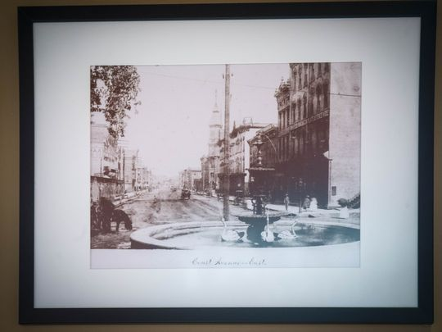

Court Avenue Brewing Co. owner Scott Carlson has placed historic photos of Court Ave on the walls of his estblishment such as this photos looking east from the courthouse. He is celebrating the 20th anniversary of the brewery and restaurant in Des Moines. (Photo: Rodney White/The Register)

Soon, the handsome five-story Italianate building, lined with historic photos on brick walls, warmed by wood floors and deep, comfortable booths became the place to go for folks going downtown for a show at the nearby Des Moines Civic Center or an Iowa Cubs ballgame.

Carlson eventually left for a couple years to become an area wine distributor but came back in 2001 to partner with the building’s owner, Lloyd Linn, and restore the brew pub.

The business soon went by the affectionate acronym CABCO and took off as the area around it grew. Today, pedestrians fill the avenue on weekends, as Carlson helped push for better lighting and converting the one-way street to two-way.

Carlson said he no longer gets restless to move; he can get a great meal right in a city that has thrived since those days, and still hop on a plane from the middle of the country and go anywhere relatively quick.

Kristin and their children Leigh, 16, Garrett, 13, and Wyatt, 10, have settled in nicely in Des Moines.

But all the good karma in the world doesn’t work to stay in business without good food, he knew.

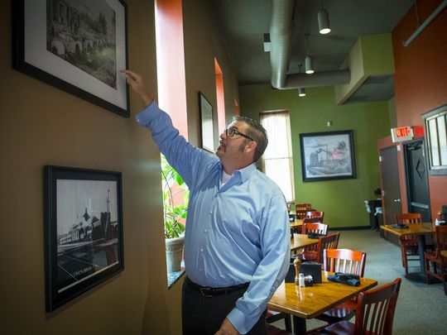

Court Avenue Brewing Co. owner Scott Carlson has placed historic photos of Court Ave on the walls of his estblishment. He is celebrating the 20th anniversary of the brewery and restaurant in Des Moines. (Photo: Rodney White/The Register)

**He lined up chefs** originally from Mexico City and New Orleans and a menu of robust comfort food was joined with traditional brown ale, stout and pale ale that took the names of pre-Prohibition Iowa breweries.

The made-to-order jambalaya and the bread pudding as big as your head became a hit, as did the Pointer Brown Ale and Blackhawk Stout beers.

When famous people came to town, they found their way there, signing one of CABCO’s beer mugs, including Jerry Seinfeld and “Apollo Creed” actor Carl Weathers and sports announcer Bob Costas, who signed a baseball.

The craft brew trend added new competition; today, 58 craft breweries make beer in Iowa. Carlson said CABCO changed with the times, sharpening up their beers to even bolder flavors in the pale ales to meet a more educated drinker, and changed the menu every year — except for those beloved favorites — to keep his focus on the food.

“People can get a craft brew and cheeseburger anywhere,” he said.

He often told his servers and bartenders he wanted their input and wanted them to grow with its success but wouldn’t hesitate to help them find their own career path.

Megan Grandgeorge was a server but was trained in public relations, so she said Carlson let her become a liaison to downtown commerce groups. She eventually left for a career in a nonprofit, while joining husband/chef Tag at the well-regarded Beaverdale restaurant called Le Jardin.

“Scott let it all happen, let us go with the flow,” Megan Grandgeorge said. “But we held each other accountable. We became the CABCO kids.”

The fish and chips with Court Avenue Brewing Company brewed root beer served at the restaurant at 309 Court Ave. in downtown Des Moines, on Friday afternoon Feb. 28, 2014.  Bill Neibergall/The Register

**A family environment formed** among employees. Wertzberger not only said he owes his professional life to CABCO as a partner in the new Gilroy’s Pub + Kitchen + Patio, but held his bachelor party, rehearsal dinner and post-wedding party there.

“So it’s a personal thing to me,” said the former server and CABCO general manager.

He said he learned how to empower employees and take pride in the work but also how to sell those feelings.

So did the former bartender Berkley, who came back to CABCO as general manager after a stint with Full Court Press.

“I tell people not to worry about money now,” he said. “If you pursue happiness and are diligent, it will happen. Not just lying under a tree, although that would be cool. But if you enrich people around you, guess what? The money shows up.”

It all came from the brew pub’s caring environment, he said. When his mother was killed in a violent crime in 2004, his CABCO co-workers were there for him.

“I went into a serious tailspin,” he said. “I spent 14 days not even being able to take care of myself. This CABCO community took turns, making me meals and staying with me. They were washing me up, bro. You gain a family member when you treat someone like family.

“That helps you shape decisions. It gets you to pull over on Hickman and help out.

‘Hey man, we’re going to take care of you.’ "