<http://www.desmoinesregister.com/story/money/business/2016/12/26/iowan-hopes-make-his-fortune-saving-workers-lives/94690614/>

Gabriel Glynn, a tech entrepreneur, is working on a device to monitor the workplace environment around a worker and alert management to potentially hazardous situations. Rodney White / The Register

Every day around the world, [more than 1,000 people](http://www.ilo.org/legacy/english/protection/safework/worldday/report_eng.pdf) die in workplace accidents, the United Nations estimates.

Gabriel Glynn, of Ankeny, believes he can help save at least some of them.

A serial entrepreneur, Glynn's latest endeavor seeks to outfit factory workers with wearable technology, tracking working conditions to help prevent injuries and deaths.

"That's 365,000 moms and dads and brothers and sisters that don't go home from work," said Glynn, 33, who is one of [The Des Moines Register's People to Watch in 2017](http://www.desmoinesregister.com/peopletowatch). "And we thought, 'If we create this, there's a good chance that we're going to send more of those people home'."

After a couple of rounds of fundraising and prototypes, Glynn is finalizing the design and software while testing versions of his MākuSafe in Iowa factories. He expects to officially launch the product onto the market in 2017 or early 2018.

“We have a moral responsibility to make sure that workers who showed up to work today are still alive to punch the clock tomorrow.”

**U.S. Labor Secretary Thomas Perez**

The sensors track everything from temperature to sound levels to humidity on a manufacturing floor. MākuSafe automatically notes when someone trips or falls.

The tool could prove especially useful in tracking near-misses, which experts believe help predict future accidents but are vastly under-reported in workplaces.

In 2015, deaths from workplace-related injuries in the United States increased to 4,836, the highest yearly total since 2008, according to the Bureau of Labor Statistics.

In a Dec. 16 statement, U.S. Labor Secretary Thomas Perez said those figures underscored the need for employers to provide safe working conditions.

"We have a moral responsibility to make sure that workers who showed up to work today are still alive to punch the clock tomorrow," he said. "The fact is, we know how to prevent these deaths."

MākuSafe could help pay for itself by providing insurers with hard data on workplace risks, which could lower a factory's premiums as risks to employees are reduced.

"Honestly, I think it could be transformative to manufacturing," said Kathy Anderson, the vice president of member development and programs at the Iowa Association of Business and Industry.

Manufacturers have economic incentives for improving workplace safety and will readily invest in products that help accomplish that, Anderson said.

"I think if you're not in that manufacturing world, it wouldn’t be top of mind for you. But for our Iowa manufacturers, safety is a top concern," she said. "A safer environment also makes it a more productive environment — and a more efficient environment."

'I'm kind of weird'

Glynn, a Cedar Rapids native, learned about the world of manufacturing through his father, who worked for 23 years as a machinist at a Goss printing press plant.

After that plant closed, his father went back to school and became a safety manager at the Nordstrom fulfillment center in Cedar Rapids.

Nine years ago, Glynn was working in loss prevention at a Target store. On a camping trip, his father told him of a business idea he had dreamed up long ago: photographing and documenting the wealthy people's possessions for insurance purposes.

“I'm kind of weird in that I'm passionate about the business side of things.”

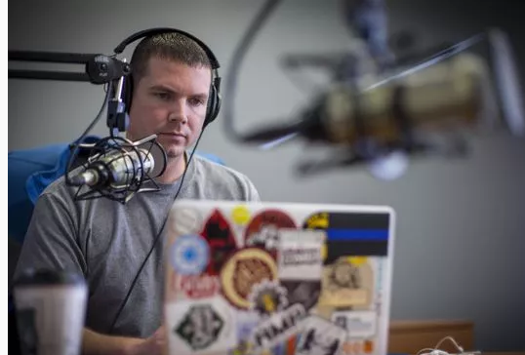

**Gabriel Glynn**

"I thought, that's actually a good idea," Glynn said. "So I quit my job in retail, and that was my first business."

That company eventually grew to a franchised business, which Glynn sold. Since then, he's been involved in the formation of several companies, most of which have been in software.

He's made his living by selling previous businesses, and he receives some sponsorship payments from the [Advanced Manufacturing Podcast](http://advancedmanufacturingpodcast.com/) he hosts.

Over the years, he has grown accustomed to the startup lifestyle. He totes his sticker-covered laptop to various metro coffee shops (and the occasional bar) that serve as his office. Work compels him to pull the occasional all-nighter, even as he's sought to build a healthier work-life balance.

Much of Glynn's knowledge has been self-taught. He has dabbled in programming but generally serves as the visionary of his businesses, relying on skilled hands for help with technical execution.

"I'm kind of weird in that I'm passionate about the business side of things," he said. "I'm passionate about fundraising, negotiating deals, patenting and developing distribution network channels."

'Blowing it all on one shot'

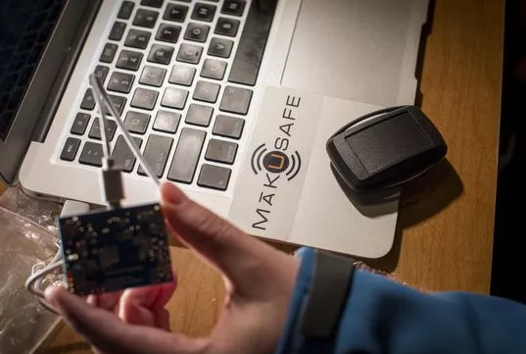

**Gabe Glynn works at Java Joes on his wearable safety device Thursdsay Dec. 8, 2016. Glynn, a youngish entrepreneur from Ankeny who has a background in marketing and web development. He left his web development firm probably about 9 months to a year ago to work on a new wearable technology, Makusafe, that’s meant to reduce safety incidents in manufacturing plants. http://makusafe.com/#/explore He also produces a podcast on advanced manufacturing.***(Photo: Rodney White/The Register)*

Glynn said he and his wife have poured their life savings into the company. He is the majority shareholder of MākuSafe, he said, and the company has raised more than $500,000 through several rounds of fundraising.

In 2017, he plans to raise another $2 million as the team perfects the product.

He said he leans on his wife, who works in advertising, and his faith to get by. The family recently sold a townhouse it had been renting out and cashed in some stocks to make it through the next six months.

“If this doesn't go very well, I'll find myself putting a lot of pieces back together.”

**Gabriel Glynn**

"There are times when it's scary," he said. "But, at 33 years old and with the people around us, we're pretty confident we'll be able to get through it."

Aside from the money, the entrepreneur said he's cashed in on many relationships he's built through serving on committees and boards throughout the region. Those contacts have become board members, advisers and investors in MākuSafe, he said.

"We're kind of just blowing it all on one shot here," Glynn said. "If this doesn't go very well, I'll find myself putting a lot of pieces back together."

The concept began as a device strapped around a worker's upper arm. One prototype looked like a small garage door opener that could be clipped to a pocket.

But the final version will resemble a Fitbit, easily worn around the wrist, like a small watch. Hopefully, workers will forget they're wearing it, Glynn said.

He said no similar products exist on the market, but the concept is out there: Many insurance companies already track some factory information, including speed and braking on fleet vehicles to help assess risk.

Those telematics products have trickled down to the general consumer market as a way for drivers to lower auto insurance premiums.

"We kind of envision that, in the next five to 10 years, it's going to be like that with workers," Glynn said.

'This project is fascinating'

Chuck Sjogren, vice president of Diversified Technologies, the George, Ia., parent company of Sudenga Industries and Dur-A-Lift, is drawn to the wearable technology because it can help fix problems before they're noticed on the factory floor.

For example, its location-based data could pinpoint an area of the plant where employees frequently slip. The device's temperature and humidity readings might show that the falls were caused by something as simple as high humidity in warmer months causing condensation on the floor.

"Then, in turn, you adjust your airflow systems," Sjogren said. "You, in essence, took a near miss and can solve that so that the humidity never reaches a certain level."

Especially important, he said, is the product's promised suite of analytics, designed to help interpret the thousands of data points recorded by employees' devices. With plans to get the device costs below $45 a piece, Sjogren believes insurance firms might help or fully foot the cost of implementation.

"This project is fascinating to me," he said. "It has the opportunity to make employers more proactive around health and safety than they ever have been."