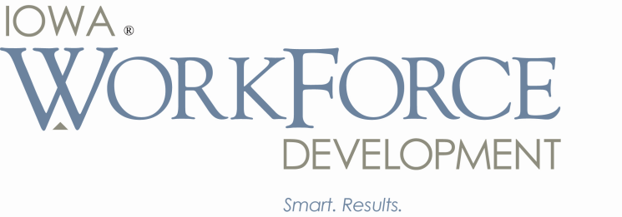Terry E. Branstad, Governor

Kim Reynolds, Lt. Governor

Beth Townsend, Director

January 4, 2016

40 Under 40 Nominating Committee

The Depot at 4th

100 4th Street

Des Moines, IA 50309

Dear Nominating Committee:

It is with great enthusiasm that I nominate Edward T. Wallace for the Business Record 40 Under 40. Ed is a dynamic and inspirational leader who serves the citizens of Iowa and the Greater Des Moines community on a daily basis. Both professionally and personally, Ed demonstrates the attributes, skills and commitments that this distinguished award is designed to recognize.

As the Deputy Director for IWD, Ed has been a stalwart in ensuring the agency provides leadership and stability to Iowa’s workforce. For the past five years, he has been dedicated to helping his fellow Iowans find meaningful employment. He has helped oversee an agency that includes four divisions and over 650 employees, located at 19 locations throughout the state. Working in what has been a very challenging role in one of the state’s largest agencies, Ed’s positive attitude, commitment to excellence and outstanding leadership has directly contributed to IWD successfully navigating the stormy waters of the past several years. His unconditional support and invaluable assistance to me in the past year has helped to ensure a successful transition between administrations as well as directly contributing to the significant and successful changes being made at IWD. In addition to his Deputy Director duties, he is the administrator for the State of Iowa Labor Market Information Division overseeing U.S. Bureau of Labor Statistics information, Labor shed studies, and Quantitative data requests and legislative liaison. I asked Ed to take on this role while we faced challenges in staffing at the senior leadership level. Ed jumped in with both feet and his enthusiasm for the bureau was infectious. He has changed the bureau from a slow-moving, intransient bureau to one of the most nimble, flexible and customer responsive bureaus in the entire agency. Ed was so committed to this goal that I made him the permanent administrator.

One of Ed’s biggest contributions to the agency is his extensive network of contacts in all walks of life. Ed knows and likes just about everyone and I routinely hear how well thought of Ed is across various communities, including state government, legislators, business and industry or every day Iowans. Among his accomplishments, Ed has developed a statewide public/private workforce and economic development partnership with over 14,000 Iowa employers. Additionally, he effectively developed numerous programs with IWD stakeholders in over 340+ Iowa school districts to expand educational and employment opportunities to our fellow Iowans.

Before coming to IWD, Ed was president of the Iowa Taxpayers Association (ITA), a statewide non-partisan membership supported organization representing 160 Iowa employers. In his role at ITA, Ed was responsible for the day-to-day operations including member services and government relations, while supervising nine employees. During his tenure, total membership grew by 24 percent.

Ed’s diverse background includes working as a compliance specialist at Nationwide Mutual Insurance Company, media specialist/community outreach coordinator for U.S. Department of Justice in Des Moines, and special assistant to the Chairman, U.S. Senate Committee on Finance, where he coordinated oversight hearings for U.S. Senator Charles Grassley of Iowa.

In 2014, Ed earned his Master of Business Administration degree at the University of Iowa Tippie School of Management. He graduated from Simpson College in 1999 with a Bachelor of Arts degree in criminal justice/political science.

Ed serves on numerous boards and committees, including Future Ready Iowa Working Group, Iowa Department of Revenue New Jobs Tax Credit Working Group, Employers’ Council of Iowa and the Governor’s Career and Technical Education (CTE) Task Force. In his “spare” time, he volunteers and is a member of the Des Moines Catholic Football League Board of Directors, Junior Achievement, Knights of Columbus and coaches numerous youth sports teams.

Page 2

January 4, 2016

40 Under 40 Nominating Committee

More important to me than his phenomenal work record, is Ed’s love of his family. He and his wife, Jen have two sons, Jack and Tate and one of the things I admire about Ed the most, is that he is a good father to his boys. He participates in every aspect of their life and is a “hands on” parent despite his heavy work load. While being a great father rarely results in public accolades, I have no doubt it will result in Jack and Tate Wallace growing to be successful human beings. The Wallaces attend St. Francis of Assisi Catholic Church in West Des Moines.

Without reservation I nominate Ed for the esteemed award of being named 40 Under 40 by the Business Record. He is exactly the kind of young man and role model, in all areas of his life, that should be recognized with this prestigious honor because he is truly making a positive difference in the lives of Iowans on a daily basis.

Sincerely,

Beth Townsend, Director

Iowa Workforce Development