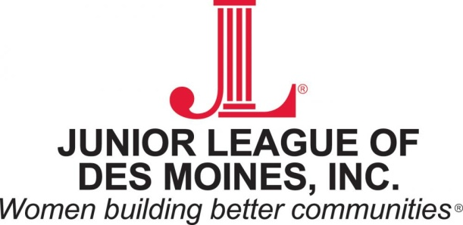

January 6, 2016

Selection Committee – Forty under 40
Des Moines Business Record
100 Fourth Street
Des Moines, Iowa 50309

Re: 2016 Nominations - Forty under 40 Awards

Dear Members of the Selection Committee,

My name is Anne Happel and I am a Past-President of the Junior League of Des Moines.

Founded in 1926, the Junior League of Des Moines (JLDM) is an organization of women committed to promoting voluntarism and to improving the community through the effective action and leadership of trained volunteers. Our local membership base totals over 600 members, 100 of which are active volunteers.
.
I joined league in 2006 after transferring to Des Moines while working for The Principal Financial Group from which I retired in 2010 after 20 years of service. Since then, I have held several leadership positions within our organization and have had the pleasure of working with many exceptional and accomplished women and I was compelled to nominate the following League members for this year’s Forty under 40.

- Sonia Ashe
- Brooke Axiotis

Both of these women contributes so much to our organization, their professional careers, and various civic organizations and to the community in general, not to mention their friends and family. They uniquely exemplify outstanding civic and community leaders and have gained my utmost respect. I am proud to nominate them.

Sincerely,

Anne Happel
Past-President, 2013-2014
Junior League of Des Moines

