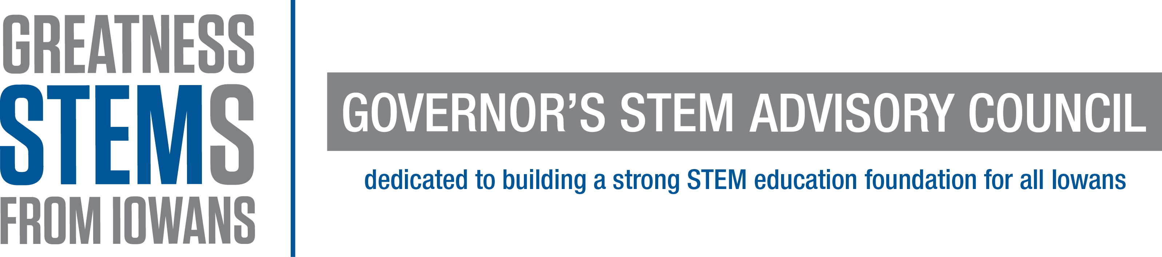

January 12, 2016

Dear Jason,

It is my privilege to nominate Kimberly Wayne for a 40 Under 40 award. I met Ms. Wayne when she was appointed to serve on the South Central Iowa Regional STEM (Science, Technology, Engineering, Math) Advisory Board by Governor Branstad, two years ago. As a member, she enriches our board with her time, talents, and perspective as a STEM professional, educational advocate, and member of groups under-represented in STEM fields.

In a meeting about how to reach more students from under-represented groups in STEM, Ms. Wayne advised the board to “Make sure the leadership reflects the population you are trying to reach”. As a chemical engineer, MBA, Lean Six Sigma Black Belt, and woman of color, Kimberly Wayne walks that talk. In addition to her full time job as the Continuous Improvement Regional Manager of Siegwerk and her leadership on the South Central STEM Advisory Board, she is the Executive Director of Jewels Academy. Jewels Academy is an organization that provides STEM workshops and events for elementary through high school girls. Since 2012, Jewels Academy served 180 girls from diverse racial and socio-economic backgrounds. Jewels Academy’s Young Emerging Scientist program introduced participants to over fifteen STEM professionals including software engineers, statisticians, medical physicians, and biotech scientists.

Ms. Kimberly Wayne received the Women of Innovation Diversity Champion Award from the Technology Association of Iowa in November. It was for her work founding and directing Jewels Academy. She said “My inspiration stems from my personal journey and the struggles of becoming an engineer, but also the rewards of accomplishing such a task. My goal is to make the path a little easier for the next generations. I enjoy empowering youth. Young women have more obstacles; therefore, I feel led to serve in the community by encouraging and inspiring young women by removing unnecessary obstacles. “

Ms. Wayne is working on adding another tool to her array of leadership instruments. She is currently enrolled in the Educational Leadership Doctoral Program at Drake University, and will complete her Ed.D. degree in 2018. Kimberly Wayne’s driven leadership and advocacy for women in STEM elevates the entire community. She is an excellent candidate for the 40 Under 40 Award.

Sincerely,
Sarah Derry

Sarah W. Derry, Ph.D.
South Central Iowa Regional STEM Manager
Drake University
Iowa Governor’s STEM Advisory Council

