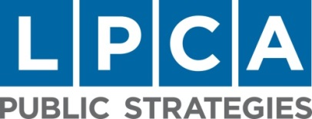

Business Publications   
Attn: Jason Swanson   
100 4th Street   
Des Moines, IA 50309   
  
RE: *Forty Under 40* Recommendation

Dear Judges,

I am writing to enthusiastically recommend Mike Barratt for the 2016 *Forty Under 40* class. His impressive blend of professional and philanthropic accomplishments makes an ideal addition.

Mike serves as a Vice President – Financial Consultant at Charles Schwab where he manages a $400 million financial services practice. Barratt has built his solid business by earning trust and loyalty one client at a time. His professional prowess has earned the national distinction of being named a six-time “Circle of Excellence Award” winner.

Barratt’s success extends beyond the walls of Charles Schwab. He shares his leadership talents with a variety of charitable organizations that benefit from his knowledge and dedication. Presently, he serves on the Food Bank of Iowa Board of Directors. He is working on the committee leading the hunt for a new executive director for the statewide agency. Mike is also busy creating a new 2016 signature BBQ event called “Smoke Out Hunger” for the organization that will help raise awareness and funds for Iowans that are food insecure.

Mike served on the Variety Club of Iowa’s “Young Variety” board until 2015. During that time, he co- founded a winetasting event that raised $11,000 for children in need. He also served on the “Project Variety” events committee which raised $30,000 for children in need.

Mr. Barratt is a member of the Des Moines Rotary. The Coe College graduate also holds his Series 6, 7, 63, 66 and Life & Annuities licenses.

Mike Barratt’s professional success is aspirational in many ways. However, it is his dedication to those less fortunate that makes him deserving of this award.

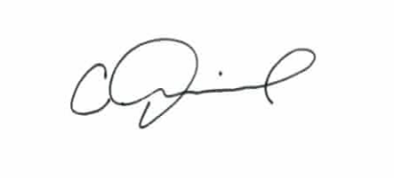All the best,

**Christopher Diebel**, MPA   
Managing Director of Public Affairs   
LPCA Public Strategies