October 25, 2013

Business Record

Des Moines, Iowa

Dear 40 Under 40 Committee:

I have had the opportunity, through the Ankeny Area Chamber of Commerce, to be associated with Travis Carlsen. Travis has been active and involved in the business community of Ankeny for several years.

Travis began his involvement in the Ankeny Area Chamber through One Source Tax and Accounting, LLC. Travis has been a leader on several committees including Ankeny Young Professionals and Ankeny Ambassadors. Through Travis’ leadership activities and skills he was recognized by many in the business community and successfully nominated to serve on the Board of Directors of the Ankeny Chamber, the largest chamber in the metropolitan area.

Travis is active through volunteerism in several areas outside of the Ankeny Area Chamber. Travis keen sense of responsibility and willingness to share his knowledge and skill is a benefit the Des Moines area is fortunate to have.

It is with pleasure that I recommend Travis Carlsen as a qualified recipient of the 40 Under 40 award.

Sincerely,

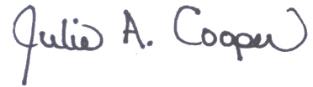

Julie A. Cooper

Executive Director