
January 9, 2017

40 Under 40 Review Committee
Des Moines Business Publications
100 4th St.
Des Moines, IA 50309

Dear Review Committee,
It has been my honor and privilege to work with Bryan Martin. Bryan has consistently been our go-to-guy for a number of Human Resource related questions and needs. In fact, we hired Bryan to conduct interviews for us because of his expertise in personality-based interviewing skills. Since then he has volunteered to assist us with programs, such as our internship program where we asked participants to go through a mock interview so we could provide feedback. Bryan has a passion for helping people in this area and has been extremely valuable asset to the Urbandale Chamber of Commerce.
In addition, Bryan gives back in a number of ways. When the Employers Council of Iowa needed a leader, we recommended Bryan. He led the organization through an important transition and helped create a more solid foundation for them to operate from.
Bryan leads with a big heart. He has served as a mentor for LGBT teens, volunteered as a member of the Duck Derby Council under Youth Emergency Services & Shelter, and is an adoptive parent of three foster children through the Iowa Foster and Adoptive Parents Association.
Education is a passion of Bryan’s and you can see that through his extracurricular activities as a DMACC Adjunct instructor and Project Iowa in Career Readiness.
Bryan exemplifies professionalism and is talented in all aspects of his career as Senior Human Resources Business Partner for Anthem, Inc. For all the reasons above, I believe Bryan would be a perfect candidate to award 40 under 40.
Thank you for your time and consideration.

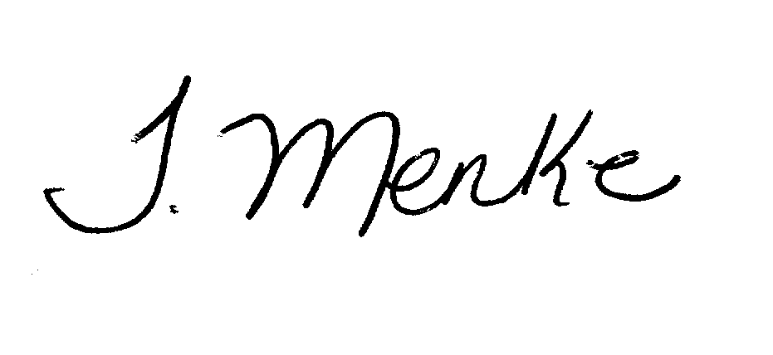
Best Regards,
Tiffany Menke, IOM
President
Urbandale Chamber of Commerce
2009 Recipient of the 40 Under 40 honor

