January 8, 2017

Dear Forty Under 40 Selection Committee,

It is my pleasure to recommend Rachel Panzi for the Forty Under 40 award. Rachel is a very deserving candidate for this recognition and will be proud to represent the Class of 2017.

I first met Rachel when she and I worked together at LifeServe Blood Center. With her strong work ethic and positive attitude, Rachel quickly earned the trust and respect of her colleagues, as well as the community members and business professionals she works with to coordinate life-saving blood drive events. Through the years, Rachel proactively looked for opportunities to take on additional responsibilities, from creating and managing a program to recognize high school students as Gallon Grads, to growing the number of blood donors and blood drive events in different regions throughout the state.

In addition to her work at LifeServe Blood Center, Rachel generously devotes her time to helping others in the community. As a member of Junior League of Des Moines, she has been involved in fundraising activities to benefit community organizations serving women and children, and has taken an active role in developing the membership within the organization.

Thank you for your consideration of Rachel Panzi as a recipient of Forty Under 40 recognition.

Sincerely,
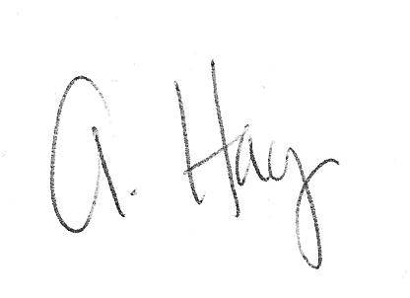
Allison Hay
Public Relations Supervisor
Two Rivers Marketing
(515) 710-3033

