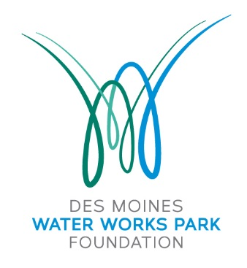

PO Box 12009

Des Moines, Iowa 50321

[www.dmwwpf.org](http://www.dmwwpf.org)

**Board of Directors**

Kate Byus

Dave Carlson

Tom Farr

Ryan Flynn

Jed Gammell

Katie Gillette

Ryan Hanser

Dylan Huey

Amy Jennings

Jon Koehn

Proctor Lureman

Ben Mclean

Gunnar Olson

Chad Rasmussen

Randy Reichardt

Claudia Schabel

Jason Stone

Marc Wallace

Matt Van Loon

Zac Voss

Hannah Inman, President

**Executive Director**

Sam Carrell

**Advisory Council**

Johnny Danos

Dr. Richard Deming

Charlotte Hubbell

Sharon Krause

Doug Reichardt

Janis Ruan

Connie Wimer

12 January 2017

40 Under 40 Selection Committee

c/o Des Moines Business Record

100 4th Street

Des Moines, Iowa 50309

To Whom It May Concern:

It is my honor to nominate Randy Reichardt as a 40 under 40 recipient. In my role as the Executive Director for the Water Works Park Foundation, past chair of the Greater Des Moines Leadership Institute, and on numerous boards and initiatives within the community, I’ve had the privilege of working with several of the young and emerging leaders in the community (many of whom grace your 40 under 40 alumni list). It is my belief that Randy represents the high standard you have set for this recognition.

Over the past year, Randy has served as President of the Board of Directors for the Water Works Park initiative. He has been an excellent leader. Thoughtful in his approach, he works to make others around him successful for the collective good.

His passion for not only the Water Works Park initiative, but the community as a whole is evident in both his work and volunteer activities. A native of Des Moines, he returned to the community to raise his family and establish his development business. He is having an immediate impact. I am constantly astounded by his vast knowledge of area projects, his relationship with the people that are making them happen, and in many cases his quiet involvement in them.

In observing his impact on our community in just the short time he has been back in Des Moines, I am sure we will hear Randy’s name involved in projects that shape Des Moines future for years to come. It is for this reason that I nominate him to this prestigious group.

Warm Regards,

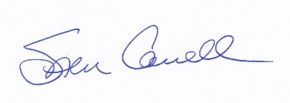

Executive Director