Insurance Exchange Building Suite 444

505 Fifth Ave.

Des Moines, Iowa 50309

Phone: 515-288-1846

Fax: 515-288-0137

e-mail: [jmcgovern@inhf.org](mailto:jmcgovern@inhf.org)

[www.inhf.org](http://www.inhf.org)

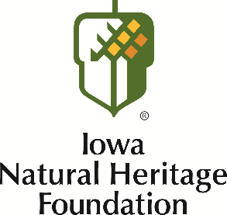

January 12, 2017

Dear Forty Under 40 selection committee,

It is impossible to look at the impact Iowa Natural Heritage Foundation has had in Iowa in the last decade and a half without acknowledging the legacy that Heather Jobst is quietly creating. Her dedication to conservation in our state has made Iowa better for more people and in more places that many realize.

Heather started working for INHF in 2001 and has worked in many different roles with us since then. Her dedication to our mission — to protect and restore Iowa’s land, water and wildlife — has translated into thousands of acres of land made accessible to the public and countless private areas being permanently protected. She has steadily worked her way up to a leadership position, now as Senior Land Conservation Director, and now oversees our land projects, stewardship and conservation easement departments. Heather has been the leader on nearly 150 land projects, totaling close to 19,000 acres of land being preserved or restored. She has also played a role in countless other projects during her time at INHF.

Beyond the numbers, it is the partnerships that Heather has forged or strengthened that have been most valuable to the work we do. She has fostered productive relationships with people and organizations from the city to the federal level. Heather has created partnerships with county conservation boards, the Iowa Department of Natural Resources and the federal Natural Resources Conservation Service to name a few. Conservation work is often like putting together a puzzle. Heather is able to see the bigger picture and put together the right people and groups to get the job done. It is these public/private partnerships that enrich our work and make Iowa a better place.

Outside of her work at INHF, it is clear that Heather is dedicated to helping people in her own time. It has been inspiring to learn about her work with ChildVoice and Big Brothers, Big Sisters.

I wholeheartedly endorse Heather’s nomination to be recognized by the Business Record for the Forty under 40 award. If there is anything else I can do to help, please let me know.

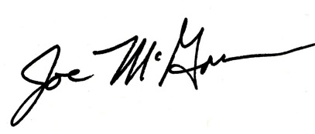Sincerely,

Joe McGovern, President