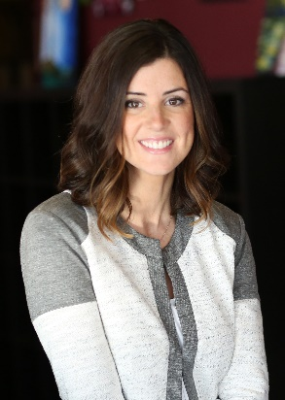**Erin Baker**

**Pinot’s Palette, Owner**

**ITA Group, Program Manager**

***Professional Accomplishments***

I have been the owner/operator of Pinot's Palette since 2013, and just recently rejoined the "regular" workforce as a full-time Program Manager at ITA Group. As a program manager, I coordinate the operation of group travel programs for specific clients, and serve as a leader for the internal team.

At Pinot's Palette, I was responsible for finding our location, lease negotiations, the build out and renovations, staffing, training, and all marketing efforts surrounding our grand opening. For the last three years we have been open, I have been the sole operator, managing scheduling, new painting submissions and the art critique process with my artists, marketing, inventory management, implementing studio processes, etc.

***Civic and Community Leadership***

In 2016 I founded Babies Need Boxes Iowa, a nonprofit organization which equips new mothers and families in Iowa with tangible resources to have a successful transition into parenthood and combat infant mortality due to unsafe sleep practices. We provide mothers with safe sleep education, a safe sleep environment, and newborn care essentials to promote self-sufficiency, and interactive items to foster positive parent-child interaction.

I am the Vice President of Marketing/Communication for the Young Variety board, which is the young professional board for Variety - the Children's Charity, voted in by my peers. I also sit on the Variety marketing committee and participate in multiple social marketing initiatives to spread awareness of the organization, and increase event attendance.

I have also been a member of the Blank Children's Hospital Festival of Trees and Lights Gala Committee for two years, procuring donations from local businesses for silent and live auction items, as well as participating in set up for the gala event. Both years I have been involved have been record breaking years, shattering set fundraising goals and further improving the lives of children who receive services and care through Blank.

I volunteer for various events and activities throughout the year through my philanthropic associations. In 2017, I hope to travel to Greece to help distribute baby boxes to new families living in refugee camps, who fled the war in Syria, through the organization Carry the Future. This is a cause I am passionate about and have contributed to through various supply drives throughout 2016.

***Education***

I received my Bachelor of Arts Degree in Advertising from the Illinois Institute of Art – Chicago where I was awarded “Best in Show” for my major, during our graduation portfolio show.

***Family***

I live in the Westwood neighborhood of Des Moines with my husband John, and my two kids, Quinn (3) and Marley (2).