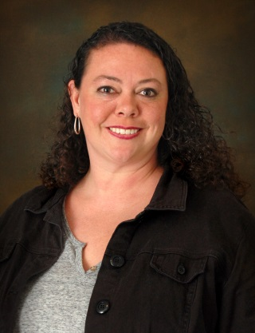



**2017 Nominee: Emily Linn**

**Date of birth:** 12/11/78 (Age 38)

**Colleges Attended and Degrees Earned:**

University of Iowa– 1997-2001

Bachelors of Science in Health, Leisure, and Sports Studies

Emphasis in Therapeutic Recreation

**Business Accomplishments:**Emily’s career at Child*Serve* began 16 years ago as a certified therapeutic recreation specialist developing individual and group activities for children and young adults with special healthcare needs. She served for 10 years as a Site Supervisor in the 24 hour/day Supporting Community Living Service before being promoted to SCL Homes Team Manager in 2016.  Her knowledge and expertise in this area are invaluable for Child*Serve* Homes.

Emily is an inspiration to the teams she leads and advocates for recognition and celebration of Direct Service Professionals who carry out our mission each day. Emily is also an expert in positive behavior support and trains others on best practices. See resume for more achievements.

Comments from Emily’s Supervisor and Colleagues:

* Team members and the children we serve are drawn to Emily because of her openness and charismatic demeanor
* She’s incredibly energetic, positive and engaged in her leadership role and encourages her team to be the same
* Emily’s always looking for new and better ways to support children and young adults
* She will always step up and take on new challenges and projects for the greater good
* Emily goes the extra mile. Instead of just arranging for one of the young women she supports to go to Zumba, Emily participates right alongside of her encouraging her all the way.

**Civic Leadership:**

**Special Olympics Iowa**

* Serves on West Central Area Management Committee (Greater Des Moines)

**Free Clinics of Iowa**

* Volunteers as Assistant Administrator for St. Luke’s Free Medical Clinic in Polk City

**Polk County Positive Behavior Support Network Academy**

* Co-Chair January 2014- Present

**Polk County Positive Behavior Support Network**

* Member-At-Large Executive Committee September 2014-November 2016

**Achievements, awards and special recognitions:**

* Child*Serve* Wellness Champion
* Child*Serve* Trainer of the Year Nominee
* Completed the Polk County PBS Leadership Academy, From Vision to Action Leadership Training
* Certified instructor in the Mandt System
* Medication Manager

**Nominated by:**Debby Eldred

West Central Area Director

Special Olympics Iowa

515-229-7733

**Supported by:**

Vickie Brink (Emily’s Supervisor)

Child*Serve* Director of Home Services 515-331-8114

Amy Richardson (Emily’s Colleague) 515-727-0284