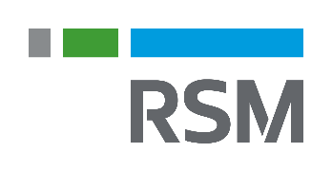

Jaci Dammeier

Senior Manager, Assurance Services  
RSM US LLP  
Des Moines, Iowa  
jaci.dammeier@rsmus.com  
+1 515 558 6676

Summary of experience

Jaci has been with the firm for 14 years and serves as an audit senior manager in two of our firms highly specialized industry teams:

As a public sector specialist, Jaci focuses on providing audit, consulting and reporting services to not-for-profit, higher education and governmental organizations. She is a firm certified not-for profit, governmental and Yellow Book specialist. In addition, Jaci is a reviewer for the Government Finance Officers Association (GFOA) Certificate of Achievement for Excellence in Financial Reporting.

As a construction/real estate specialist, Jaci provides general business advisory services, planning and managing audit engagements as well as researching and resolving accounting issues. She specializes in low-income housing tax credit issues, including compliance certifications and cost segregations, as well as contractor qualification reporting. In addition, Jaci is a Housing Credit Certified Professional.

Professional affiliations and credentials

Certified public accountant

American Institute of Certified Public Accountants

Iowa Society of Certified Public Accountants

Central Association of College and University Business Officers

Government Finance Officers Association

* Housing Credit Certified Professional

Education

* Bachelor of Arts, accounting, University of Northern Iowa

Additional information

Jaci is the treasurer of the University of Northern Iowa accounting advisory board and the past treasurer of Hawthorn Hill, a local not-for-profit agency providing low-income housing services.