### Experience

[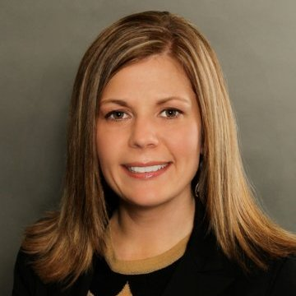](javascript:void(0))

JESSICA RINGENA

Assistant Vice President, Controller at Hy-Vee, Inc.

# sUMMARY

Jessica is a CPA licensed in the state of Iowa and serves as Assistant Vice President, Controller at Hy-Vee, Inc. Hy-Vee is an employee owned grocery retailer with 240 stores in eight states, headquartered in West Des Moines, Iowa. Hy-Vee operates full-service supermarkets including pharmacies, health markets, fuel stations, floral shops, wine and spirits, bakeries, delicatessens, market grill restaurants and cafés, and Chinese and Italian food departments.  
  
Jessica is responsible for financial reporting, consolidation, technical accounting research and sales tax reporting. She also serves is the company compliance officer and supervised the pharmacy accounting team.

## Organizations

##### Iowa society of cpa’s

November 2004 - Present

## Vitals

14615 Hickory Drive,

Urbandale, IA 50323

515-5543077

**T** Telephone

**E** Email

#### hY-Vee, INC., Urbandale, IA

##### October 2015 - Present

Financial reporting, consolidation and technical accounting research. Compliance officer, sales tax reporting and supervisor of the pharmacy accounting department.

#### RSM US LLP, Des moines, IA

##### January 2003 – October 2015

Provided audit and attestation services to clients in a variety of industries including manufacturing, health care and senior living, retail, trucking, various service industries, and employee benefit plans.   
  
Planned and managed audit and attest engagements. Oversaw the preparation and issuance of GAAP financial statements. Monitored client and regulatory deadlines. Assisted clients with research, special accounting projects, and resolving technical accounting issues.

Internal responsibilities included co-scheduling lead for 30+ staff auditors, career advisor for 4-6 staff, assisting with preparing and delivering internal and external training and participating with on-campus recruiting and interviews.

### Education

#### Missouri State University,

BS & MAcc, Accounting 1998-2002

### certifications

Certified Public Accountant, Iowa License

### LEADERSHIP

[**Children Family Urban Movement (CFUM)**](https://www.linkedin.com/vsearch/p?company=Children+Family+Urban+Movement+%28CFUM%29&trk=prof-vol_exp-org_name) **–** *See attachment for organizational description and Whyld Girls program description.*

**Board of Directors / Treasurer**

January 2014 – Present (3 years 1 month)

**Advisory Board Member & Special Events Committee**

[Whyld Girls - (CFUM)](https://www.linkedin.com/vsearch/p?company=Whyld+Girls+-+%28CFUM%29&trk=prof-vol_exp-org_name) November 2009 – December 2013 (4 years 2 months)

Whyld Girls is a program of CFUM. The program offers five-day weekly after-school programming to girls in 6th - 12th grades.