**Visiting the News Media on a Warren County Project**

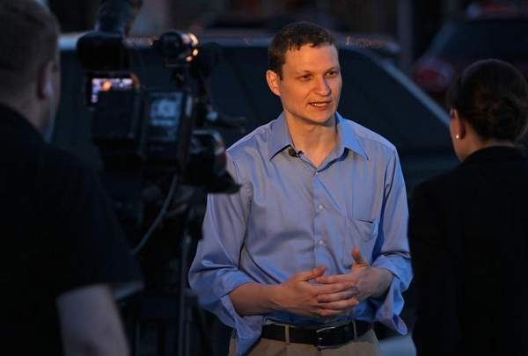

**The Warren County Economic Development Corporation staff team receiving the “Overall Program” award from Governor Terry Branstad at the 2013 Iowa SMART Conference in Des Moines**

