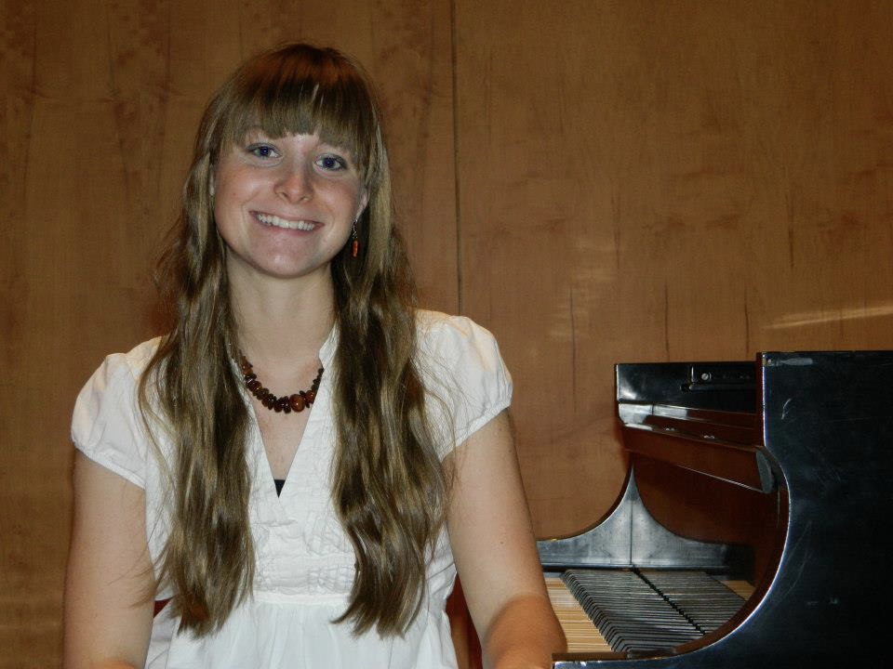

**Biography: Patricia’s Research**

Patricia’s journey into research in neuroscience and music began as an undergraduate when she completed and published an honors thesis titled “*Robert Schumann’s Illness and Its Effect on His Music*,” which explored the neuropsychiatric ailments of Romantic composer Robert Schumann. The thesis then propelled her into her graduate studies, which focuses on the neurophysiology of music using electroencephalography (used to measure general electrical brain activity) and transcranial magnetic stimulation (to measure excitatory and inhibitory electrical brain activity). She uses these techniques to examine activity of brain regions exposed to different styles of music in healthy young adults, healthy older adults, and persons with Parkinson’s disease. As she progressed through her studies, she developed a strong interest in the impact of music training on cognitive and motor inhibition, and its application from the bench to the bedside and classroom. These interests align well with her research philosophy: *research serves a purpose*, with the three pillars of her research program – clinical impacts, educational impacts, and multidisciplinary collaborations – revolving around this philosophy.

Patricia’s dissertation research focuses on the neuroscience behind cognitive inhibition (e.g. ability to limit distractibility) and motor inhibition (e.g. ability to limit excessive movement) in non-musicians and musicians across their lifespan. Both cognitive and motor inhibitions are critical components in suppressing undesirable responses in both professional and personal environments. Recent research has revealed that former music training in healthy adults improves cognitive inhibition and motor inhibition. However, it is unknown if there is a relationship between cognitive and motor inhibition (i.e. does one affect the other) in musicians vs. non-musicians. Additionally, it is unknown if musicians display neuroprotective effects on the declining cognitive and motor inhibition experienced as we age. She is investigating if musicians will display a stronger relationship between cognitive and motor inhibitory circuitry in the brain thus enhancing inhibitory behavior throughout the lifespan (as compared to non-musicians). Potential implications of the results include not only a new theoretical model of cognitive and motor inhibitory pathways in the brains of musicians but also practical applications in both clinical [e.g. mediating attention deficit hyperactivity disorder (ADHD) symptoms via music training] and educational [e.g. establishing neurobiological and behavioral evidence for benefits of STEAM education] realms.

Her research has been presented at the 2016 International Conference on Music Cognition and Perception, 2016 & 2017 Society for Neuroscience (SfN) International Conference, 2016 & 2017 Iowa State University (ISU) Neuroscience Research Day, 2017 ISU Faculty Research Day, and the 2017 Neuromusic Conference. In addition, she has had opportunities to share her lab research and research from the neuroscience and music field via public presentations and discussions for courses and organizations such as the Science Center of Iowa, Des Moines Music Teachers Association, the Music Teachers of Central Iowa, and the Methods in Music Education (undergraduate course at ISU).

**Bio: Patricia’s Teaching**

Patricia’s academic philosophy is “You become a better teacher when you do research, and you become a better researcher when you teach.” In her past two-years of graduate studies, she designed and taught a summer course (2016 & 2017) at ISU titled *Neuroscience of Music* in collaboration with the Neuroscience Interdepartmental Graduate Program, Department of Music, College of Design, and Office of Pre-collegiate Programs for Talented and Gifted. The course targeted middle school students and focused on basic principles of neuroscience, musicianship, neuroscience of music education, neuroscience of music therapy as well as professional development (i.e. guest artists and neuroscientists). Also, the course inspired Patricia to establish the Ames Public Piano Project, sponsored by the ISU Focus Artist Grant, Ames Main Street Cultural District, Ames Public Arts Commission, and Ames Parks and Recreation. The project provided the city of Ames with two community pianos that were placed in summer 2017 on Main Street and Campustown Court. In addition, she established her own piano studio in Ames where she focuses on teaching using evidence from the motor learning and control literature, neuroscience of learning, and neuroscience to maximize learning and prevent long-term injury. Her studio consists of 15 students at a variety of ages and levels who participate in two to three yearly recitals and local Iowa Music Teacher Association festivals and competitions. In the past, she taught privately at the pre-collegiate level and was a faculty member at University of West Florida Piano Week (summer 2015).

At the university level, she is a teaching assistant in BIO255L Human Anatomy Lab (fall 2017) and previously BIO211L Principles of Biology I and BIO212L Principles of Biology II Lab (fall 2016 – spring 2017). In these courses, she lectures, instructs, mentors, and assesses between twenty-five to fifty students. In addition, she serves as a teaching assistant to thirteen students in a Freshman Research Initiative course titled *Dancing with Parkinson’s Disease*. She was tasked with creating and presenting curriculum in introductory research methods in human neurophysiology, assisting and mentoring freshman with their research project proposals, overseeing accurate data collection for their research projects, and preparing students to present and discuss their project results in a professional scientific symposium held at ISU.

To propel and improve her endeavors in teaching, she received the ISU Wakonse Fellowship, which provided funding for her to attend the Wakonse Teaching Conference. Additionally, she is in the process of completing Preparing Future Faculty, a multi-university program for graduate students planning a career in academia with a focus on improving researching and teaching.

**Bio: Patricia’s Service and Leadership**

In addition to her previous leadership endeavors in teaching and research, she is involved in leadership, outreach, and collaboration with the local SfN chapter and the ISU Neuroscience Graduate Student Organization (NGSO). As vice-president of NGSO, she worked with the president to collaborate with the Science Center of Iowa, participating in outreach events like Café Scientifique, Meals with Mentors, and Girls in Science Festival. She also established and coordinated a neuroscience outreach event called Brain Day (which attracted over 70 members of the ISU and Ames community), developed a professional development seminar series for graduate students, and created a neuroscience retreat for faculty and graduate students. Recently, Patricia and a colleague received an internal grant to establish an ISU Neuroscience Graduate Learning Community with a focus on three key areas: 1) first year graduate student mentoring and retention 2) graduate professional development seminars 3) public advocacy and outreach training. They are in the process of implementing this program for neuroscience graduate students at ISU so they can have an even better professional and personal graduate experience.

As a member of the local SfN chapter, Patricia and her major professor co-chaired (respectively) the 2016 SfN Annual Meeting Symposium titled "Neuroscience of Music: Novel Discoveries and Their Implications in the Understanding of Music and the Brain". The symposium featured major researchers in the neuroscience of music field such as Nina Kraus, Daniel Levitin, John Iversen, and Elizabeth Stegemöller. An audience of over 900 neuroscientists was present for the symposium. Furthermore, she is a Society for Neuroscience Neuronline Community Leader in which she welcomes and interacts with users to the online neuroscience community, promote and participate in SfN online events, provide feedback to SfN staff on continuation of Neuronline growth, and write Neuronline resources for users. This has led to a three-year position on the international SfN Trainee Advisory Committee which supports neuroscience trainee development and enhances the trainee members’ experience in the organization as well as the field of neuroscience.

To further propel and improve her endeavors in service and leadership, she is in the process of completing the ISU Graduate College Emerging Leaders Academy, a program that focuses on teaching and developing leadership research, theory, and practice, ethics, collaboration, teamwork, innovation, diversity, and communication in the strongest and most promising graduate students and postdocs. In 2017, she won the prestigious Technology Association of Iowa’s Woman of Innovation award for Collegian Innovation and Leadership.

Patricia also is still an active performer on piano and harpsichord. She currently holds the position of choir accompanist (piano) at First Baptist Church of Ames. Recently, she has appeared as a soloist (harpsichord) at the ISU CHOP Festival, soloist (piano) on KHOI Community Radio 89.1 FM *All Things Piano*, accompanist at Iowa Chapter of American Parkinson Disease Association Parkinson’s Singing Festival, soloist (harpsichord) at the 21st International Festival of Women Composers at ISU. She has received the Fleming Award for Graduate Harpsichord/Organ Study at ISU.