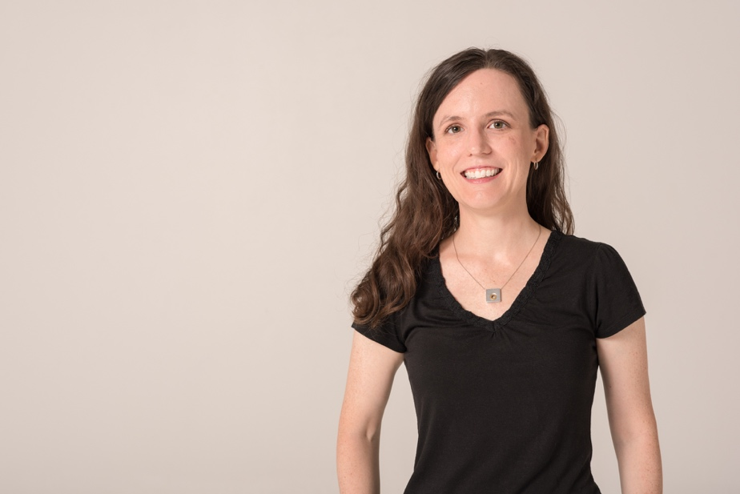

Deborah Kent is a transplant to Iowa who has flourished in Des Moines. She grew up in the Pacific Northwest, where her wide variety of interests exhibited early. In high school, she earned varsity letters in three sports and also placed 3rd statewide for an original piano composition. Governor Mike Lowry selected her as Washington State Scholar the year she graduated.

As a National Merit Scholar, Deborah attended small liberal arts college, where she enjoyed and excelled at many different kinds of courses and, in the end, graduated Summa Cum Laude with a triple-major in Mathematics, English, and German while participating in piano performance and the bagpipe band. She spent a semester studying literature at Oxford University. During her time in college, she also served as president of the A.A. Milne Literary Society and an officer in the Sigma Alpha Iota music fraternity.

After college, Deborah received a fellowship for graduate studies in mathematics at the University of Virginia. She quickly realized that extreme specialization did not align with her multidimensional interests. UVa fortunately offered a rare specialization in the history of mathematics and merged both Deborah’s humanities and technical interests. She developed the tools of both a mathematician and an historian through rigorous training in both disciplines. Deborah is motivated by a deep sense of curiosity and a love of learning combined with appreciation of technical precision and interest in encouraging the growth of others.

Deborah won a competitive post-doctoral fellowship at Simon Fraser University, where she managed teaching assistants and taught Calculus to 350+ students of biology and medicine.

She also collaborated on five different projects ranging from pedagogical publications to research on mathematics in World War I.

In her first faculty job at Hillsdale College, she taught 14 distinct courses to a wide variety of students. Deborah also developed Summer Science Camp materials and reorganized the Calculus curriculum. She introduced the department to student poster sessions and LaTeX typesetting software. In 2011, when Neptune arrived at the same location in space where it was discovered in 1846, *Physics Today* specially invited Deborah to publish an article about the historic event.

In her first year on faculty at Drake University, Deborah envisioned, designed, planned, and led 17 students on a London travel seminar—A Risky Business: The European Roots of Actuarial Science. She integrated archival work, corporate visits, and cultural events in this unparalleled opportunity. Deborah’s personal and professional travels have taken her to 35 countries, so she enjoyed introducing this life-expanding experience to others.

Deborah’s internationally-recognized research activity in the history of mathematics focuses primarily on mathematics in the scientific, institutional, and social context of the 19th- and early 20th-century United States. Unexpectedly, a previously unopened box of manuscripts at the Iowa State Historical Society figured prominently into this work! At professional conferences, she is often the only North American participant and Deborah enjoys surprising international colleagues with the reality that Iowa is a great place to live and work.

In 2015, Deborah won tenure at Drake University and promotion to Associate Professor. She has taught a wide variety of classes to diverse student audiences. Deborah’s cross-disciplinary training emphasizes the vibrant applicability of mathematics, enriches her teaching and fuels her ongoing quest for effective classroom practices. She believes in the power of integrating mathematical ideas with modern technology and her academic innovations often center on ways to incorporate technological tools in ways that respect the strengths of traditional thinking. In 2017, Deborah received a Technology Association of Iowa Women of Innovation award for Academic Innovation and Leadership. She has chaired search committees to hire colleagues similarly committed to excellence in technologically-informed mathematical education and to diversify the faculty.

Deborah recently developed a course in Numerical Linear Algebra that merges rich theoretical ideas with the experience of working with computational software. She also coauthored an innovative Game Theory text that brings advanced material into the undergraduate curriculum. She again introduced poster sessions, consequently now a staple of upper-level classes across the department. Deborah has also redesigned the capstone course to focus on effective technical communication and project management skills.

In July 2017, Deborah received a prestigious national award from the Mathematical Association of America recognizing the best in mathematical writing from 2016.  The article featured a design software adaptation of the 19th-century color technique of Oliver Byrne to an 11th- century proof from Omar Khayyam, highlighting the essence of a mathematical idea that students otherwise struggle to appreciate.

Every semester, Deborah advises ~40 students, consulting with them about course selection, mathematical majors, internships, research experience, and career options. She also mentors graduate students and colleagues. People at all levels need to know ways in which mathematics opens a host of exciting opportunities to participate in the future.

Deborah is the founding faculty advisor for Women in Mathematics and Computer Science and regularly advises and mentors students to incorporate mathematics in their futures. She has organized more than 30 professional development speakers for women in STEM and two Hour of Code outreach events. Deborah has facilitated participation in the Science Center of Iowa Meals with Mentors program. She has also coordinated STEM festival activities and worked with students who volunteer to teach coding to area middle schoolers, most recently through Pi 515 and the Forest Avenue Library. Twice, she has volunteered as a judge for FIRST LEGO League competitions at Iowa State University. After arriving in Iowa, Deborah completed the SKYWARN storm spotter training for the National Weather Service. Deborah began practicing yoga in graduate school and has been certified to teach Yoga for First Responders to process stress and build resiliency. She has worked with the director to improve the YFFR training materials.

With a wide range of interests and training, Deborah is open to ideas and has a track record of capitalizing on available opportunities for collaboration, experimentation, and learning. She enthusiastically shares her expertise, fosters curiosity, and encourages professional growth and personal development. Deborah lived in Washington, Massachusetts, Michigan, Virginia, and British Columbia before making her home in the Sherman Hill neighborhood of Des Moines. She has neither a spouse nor children.