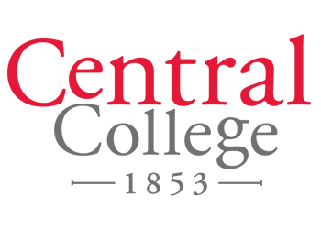

January 5, 2018

Dear 40 Under 40 Selection Committee,

I recommend Michelle Wilkie for inclusion in the *Business Record’s* 40 Under 40 awards for 2018. Michelle is an insightful professional who is driven to succeed, not only in her career, but in advancing causes about which she cares passionately.

In only a year with Central College as a major gifts officer, Michelle has made a big impact. Through her leadership and collaboration with colleagues, Central secured a significant grant that will allow for the construction of a garden classroom. This is just one example of her diligence and attention to detail leading to great things for the college. A persistently positive person, Michelle has the ability to make authentic connections with coworkers, potential donors and community members.

While getting to know Michelle, I have seen her commitment to and heart for community organizations. She has become extremely active in a short amount of time and works tirelessly to promote the objectives of organizations in Des Moines like Planned Parenthood of the Heartland and as a board member for the I Have a Dream Foundation. She believes in finding solutions to problems, and her intelligence and creative thinking are an asset to any organization.

Michelle exemplifies the professional accomplishment and civic involvement of a 40 Under 40 awardee. She is an asset to the Des Moines community and will no doubt take on many more community roles in the future.

Sincerely,

Z:\brand\Signatures\SunnyEighmy\Sunny Eighmy Black.tif

Sunny Gonzales Eighmy

Vice President for Advancement

Central College