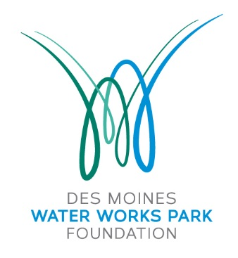

PO Box 12009

Des Moines, Iowa 50321

[www.dmwwpf.org](http://www.dmwwpf.org)

**Board of Directors**

Dave Carlson

Ryan Flynn

Jed Gammell

Katie Gillette

Ryan Hanser

Dylan Huey

Hannah Inman

Jeff Inman

Amy Jennings

Jon Koehn

Proctor Lureman

Gunnar Olson

Chad Rasmussen

Randy Reichardt

Jason Stone

Marc Wallace

Matt Van Loon

Zac Voss

Kate Byus, President

**Executive Director**

Sam Carrell

**Advisory Council**

Johnny Danos

Dr. Richard Deming

Charlotte Hubbell

Sharon Krause

Doug Reichardt

Janis Ruan

Connie Wimer

10 January 2018

40 Under 40 Selection Committee

c/o Des Moines Business Record

100 4th Street

Des Moines, Iowa 50309

To Whom It May Concern:

It is my honor to nominate Randy Reichardt as a 40 under 40 recipient. In my role as the Executive Director for the Water Works Park Foundation, past chair of the Greater Des Moines Leadership Institute, and on numerous boards and initiatives within the community, I’ve had the privilege of working with several of the young and emerging leaders in the community (many of whom grace your 40 under 40 alumni list). It is my belief that Randy represents the high standard you have set for this recognition.

For the calendar year of 2016, Randy served as President of the Board of Directors for the Water Works Park initiative. He was an excellent leader. Thoughtful in his approach, he worked to make others around him successful for the collective good. Perhaps even more telling however, is how he continued to lead effectively as Past President of the organization. He took on the task of connectivity to make sure our project would be easily accessible. He helped shape the final design of the first phase projects. And when our new President vacated the development role to take her new position, Randy graciously stepped in to that role to assure we would continue to raise the resources necessary to make this project world class. Randy has helped establish a legacy of outstanding leadership at DMWWPF and ironically has followed or proceeded 3 Presidents in our organization’s short history, 40 under 40 recipients all: Zac Voss - 2008, Kate Byus - 2009 and Hannah Inman, class of 2013.

His passion for not only the Water Works Park initiative, but the community as a whole is evident in both his work and volunteer activities. A native of Des Moines, he returned to the community to raise his family and establish his development business. He is having an immediate impact. I am constantly astounded by his vast knowledge of area projects, his relationship with the people that are making them happen, and in many cases his quiet involvement in them.

In observing his impact on our community in just the few years he has been back in Des Moines, I am sure we will hear Randy’s name involved in projects that shape Des Moines future for years to come. It is for this reason that I nominate him to this prestigious group.

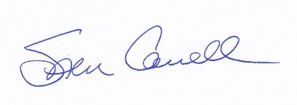Warm Regards,

Executive Director