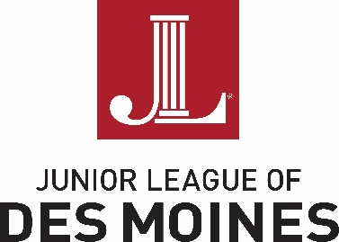

January 11, 2018

To the Forty Under 40 Selection Committee:

It is indeed a pleasure to write a letter in support of Rachel Dahlen’s nomination to the class of 2018 Forty Under 40. I’ve gotten to know her over the years as a valued member of Junior League of Des Moines and been impressed with her dedication, insightfulness and follow through as a volunteer. Our organization is built upon women supporting women in leadership development become community leaders. I have no doubt Rachel is already one of those great leaders and will only continue to do more in the years to come.

Rachel chairs our Leadership Development and Placement Committee and has been very proactive in not only in the transition time to assist incoming and outgoing leaders to connect, but also in the active solicitation and encouragement of the next generation of leaders in our organization. We are grateful for the engagement she has demonstrated to make this process as seamless as possible. An organization that relies solely on volunteers is only as strong as its membership and leading that effort takes strong leaders like Rachel.

Her additional community involvement is also a wonderful example of the type of candidates worthy of this recognition exhibit. We are fortunate recipients of her career expertise in leading physicians which translates well into all aspects of leadership development. It is without hesitation that I join the praise of Rachel Dahlen for consideration.

Sincerely,

Erica Axiotis

Junior League of Des Moines President 2017-18