Brett Smith

Region Bank President

Eastern Iowa/Illinois

Wells Fargo Community Banking

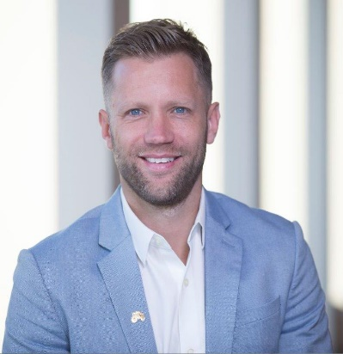

Brett Smith currently holds the title of Region Bank President for Community Banking. Responsible for Wells Fargo’s community banking operations in Eastern Iowa and Illinois. He oversees a 396-member team that serves consumer and small business customers with $2B in assets in 42 stores and 12 communities, including Chicago, Cedar Rapids and Quad Cities.

Smith was born in 1978 in Guthrie Center; he graduated from Buena Vista University in 2001 with a degree in Banking and Finance. He is a graduate of the prestigious Greater Des Moines Leadership Institute.

He joined Wells Fargo in 2001 as a personal banker. He served as a branch manager and a district manager in Des Moines before being named area president in 2011.

Brett is President of the Board for the I Have A Dream Foundation in Des Moines, a board member of Iowa State University’s College of Business Dean’s Advisory Council, a board member of the Iowa Bankers Association, and recently joined the board of the Boys and Girls Clubs of Central Iowa. He is also very active with Wells Fargo Team Member Networks, United Way, Greater Des Moines Partnership.

A native of Guthrie Center, Iowa, Smith currently resides in Waukee with his wife, Abby, and 3 children, Brady (10), Bo (7) and Andi (5).