January 7, 2014

Dear Forty Under 40 Committee:
It is a pleasure to share my support for Trina Flack as a candidate for Greater Des Moines and Business Publications Forty Under 40 Award.
Trina has been an associate at the CVB since 2009. She was hired as a Sales Manager but then was quickly promoted, due to her exemplary work, to National Sales Manager. She is responsible for enormous increases in booking many new conventions to our area.
She is also gifted with many leadership skills, including involvement with her children’s school as well as many other civic concerns. In fact, she has been appointed as a Commissioner to the Ankeny Planning and Zoning Board, thereby helping to shape the future of her hometown. Trina has also been an active member and advocate for the Iowa Society of Association Executives. She has served as President of this group in 2013-2014. Trina has the drive and passion to make Greater Des Moines even greater!
I believe Trina Flack would be an awesome candidate for this great program. Thank you for your consideration.
Sincerely,
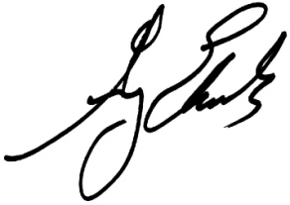
Greg Edwards
President & CEO

