

December 26, 2018

Forty Under 40 Committee

100 Fourth Street

Des Moines, IA 50309

Dear Business Record Forty Under 40 Nomination Committee:

I read somewhere that grace is the disposition or benefit to serve another. That grace is kindness and compassion. Grace is Jennifer (Jen) Cross.

I’ve had the privelage to serve alongside Jen in a variety of professional settings from boards to educational experiences. Her grace and desire to do for others is why I am nominating Jen for the Business Record’s Forty Under 40.

Jen’s work with Catch Des Moines is top notch and continues to grow tourism success in Greater Des Moines. She is a master at building relationships and is a person who is true to her word and stands by the commitments. Often you will find her bouncing to multiple events in an evening to keep all of the balls in the air, but she does this with a smile on her face and a way of grace about her.

In the community, Jen gives back in many ways. Jen currently serves on the John Stoddard Cancer Center Advisory Board, Rally Against Cancer Committee Member, Big Brothers Big Sisters Big Duo, Winefest Grand Cru, St. Ambrose University Alumni Communications Council and is a spin coach at CampusCycle in Ankeny. She is currently a member of the Greater Des Moines Leadership Institute Community Leadership Program Class of 2019, and I can personally say she shines while learning too! Her drive and passion for success and grace are key components that will continue to serve her and the Greater Des Moines community well.

I feel privileged to have worked alongside Jen and see grace in action. Moreover, I am even more grateful to call her friend. In my book, she is the ideal candidate for the Business Record’s Forty Under 40.

With Kind Regards,

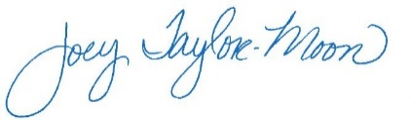

Joey Taylor-Moon

Director of Marketing

Hubbell Realty Company