2018

RE: Letter of Recommendation Tim Bratvold

Dear Selection Committee Members:

Thank you for taking precious time to complete the important and time-consuming task of selecting next year’s class. I know first- hand how important it is to select the right blend of good people. Everyone looks good on paper, but I attest that Tim Bratvold is as good a candidate as they come. You can be assured that moving his application to the top of your selection pile is a solid decision. I recommend him to you as a wonderful candidate!

I first met Tim in his role as Director of Business Development with Estes Construction. I was immediately impressed with his positive attitude, willingness to learn and connect with others. I could tell he was a rising star. A few months later his boss asked me what their company might do to enhance their offerings in the greater Des Moines area. I remember telling him they had already taken a huge step…unleashed a secret weapon…that I was uniquely impressed with Tim Bratvold and that I literally “see him everywhere”! He exhibits an incredibly positive spirit and a genuine interest in growing his company and the greater Des Moines community.

As I have learned more about Tim, I can tell you he is passionate about supporting disadvantaged youth in our community and also collaborating with other leaders to strengthen the Greater Des Moines Metro. He is now a graduate of the Greater Des Moines Leadership Institute – Class of 2018. He serves on the Luther Park Community Board of Directors, the Wellmark YMCA board of directors and serves on the Big Brothers Big Sisters YP board of directors. I see his smiling face almost every Friday morning as a fellow member of the Des Moines AM Rotary. I know he is making a difference in every organization he serves.

I believe Tim exemplifies the emerging leader.

Sincerely,

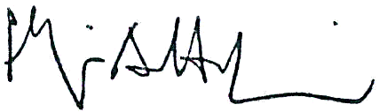

Philip A. Hodgin, AIA
RDGIA Principal/ Partner/ RDG CEO

